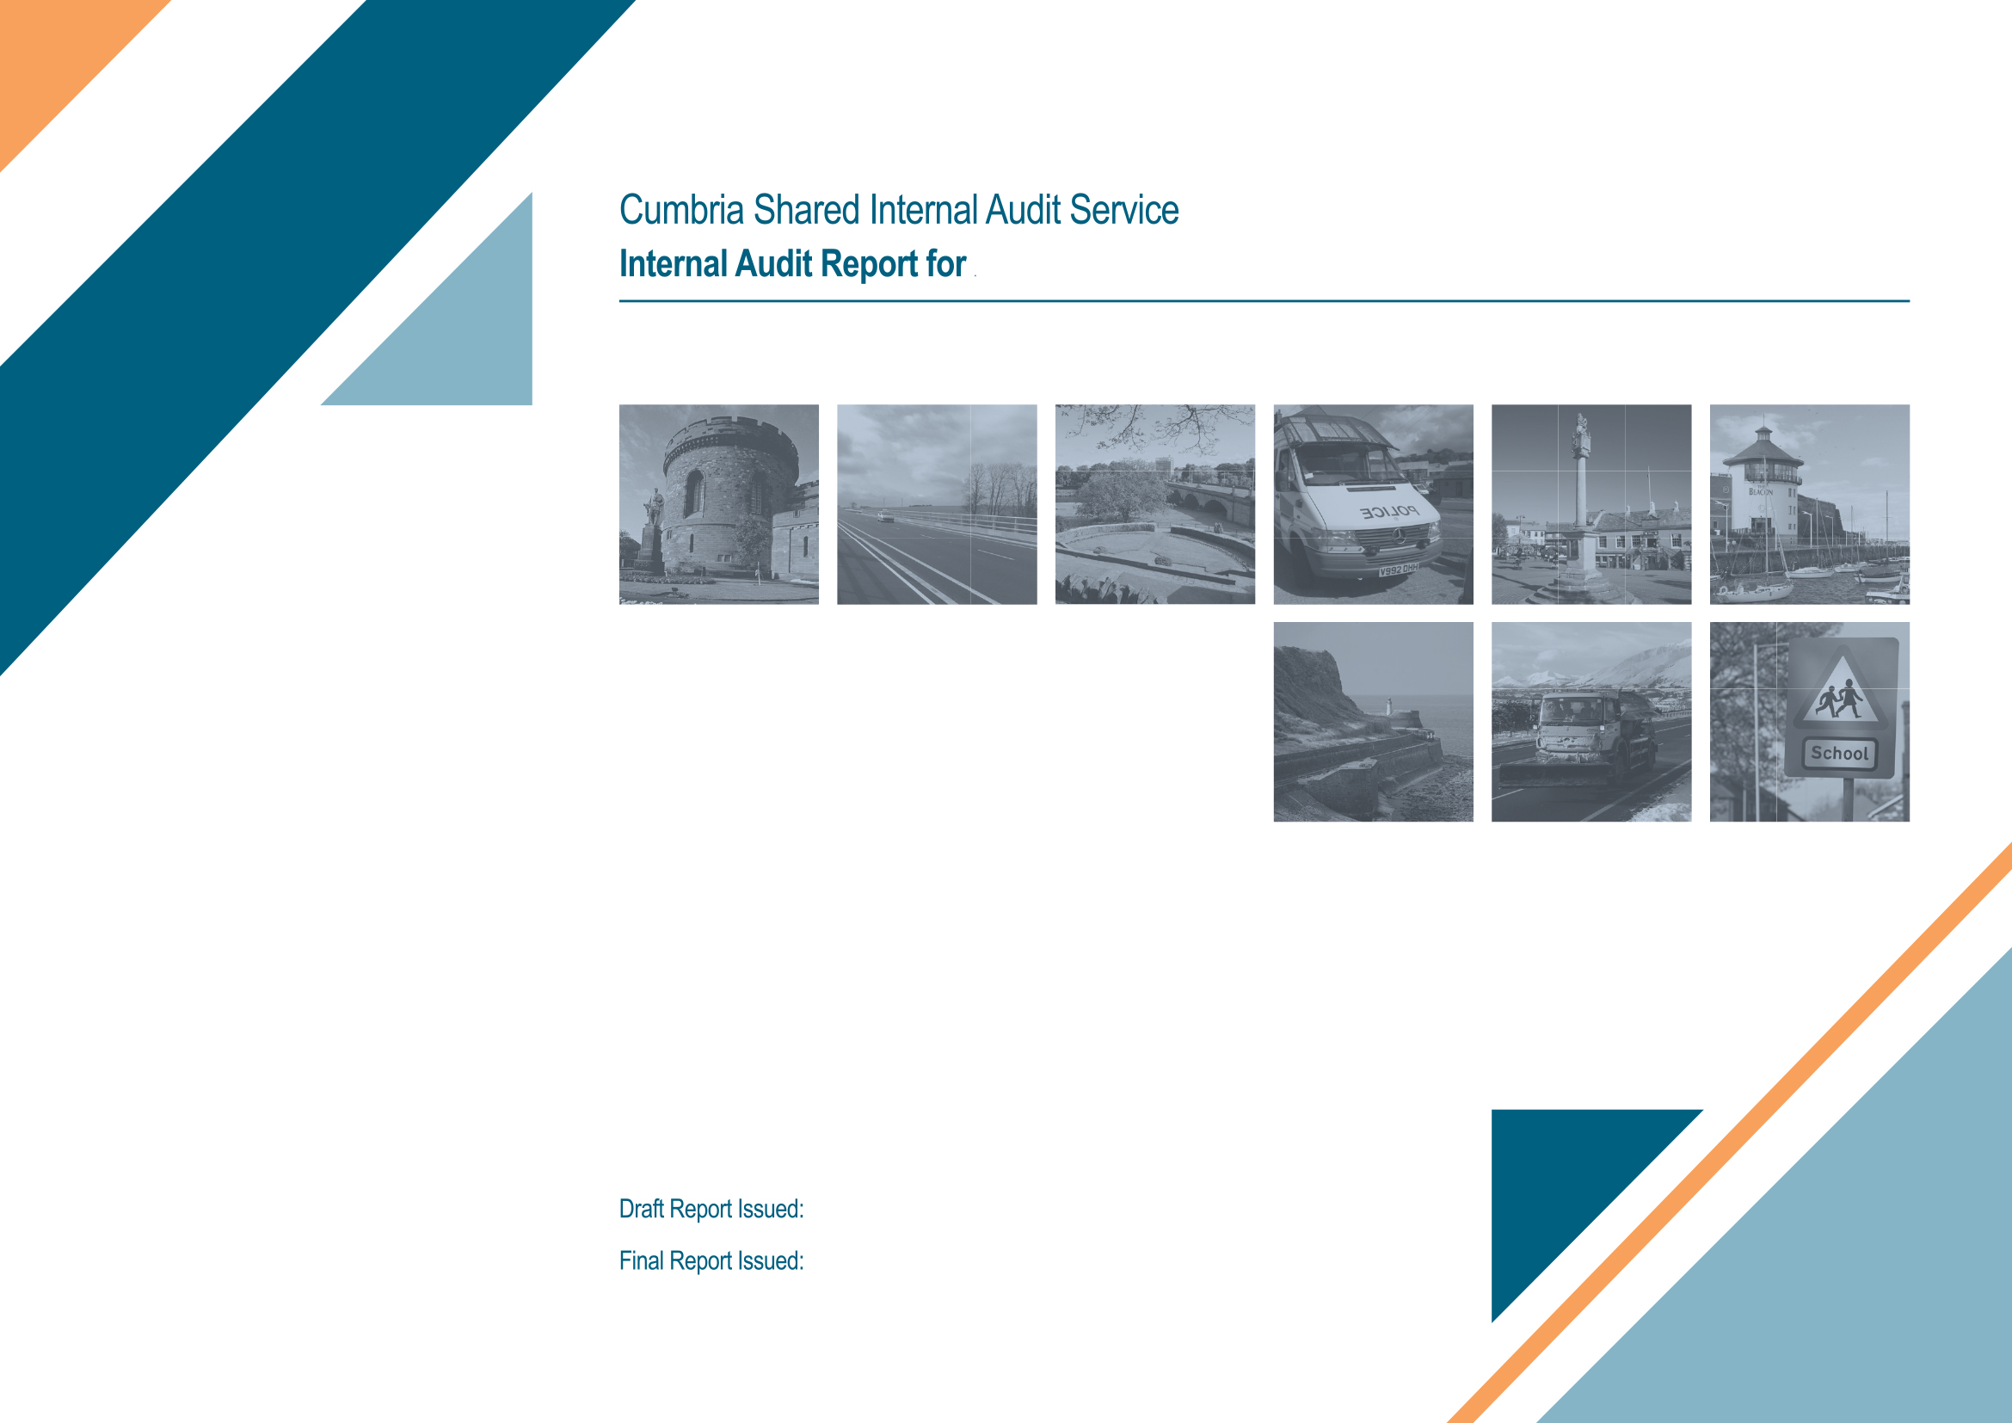
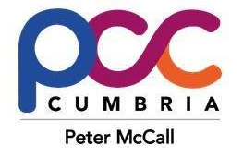
OPCC and Constabulary
27th February 2018
7th February 2018
Detailed procurement testing

Audit Resources

Title | Name | Email | Telephone
Audit Manager | Emma Toyne | emma.toyne@cumbria.gov.uk | 01228 226261
Lead Auditor(s) | Janice Butterworth | Janice.butterworth@cumbria.gov.uk | 01228 226252

Audit Report Distribution
For Action: | Chris Guest (Head of Procurement)
For Information: | Stephen Kirkpatrick (Director of Corporate Support)
Audit Committee | The Joint Audit & Standards Committee, which is due to be held on 21 March 2018 will receive the report

Note: Audit reports should not be circulated wider than the above distribution without the consent of the Audit Manager.
- Background

  - This report summarises the findings from the audit of detailed procurement testing. This was a planned audit assignment which was undertaken in accordance with the 2017/18 Audit Plan.

  - Detailed procurement testing was originally included in the 2016/17 internal audit plan but was deferred because a risk based audit of compliance with the Joint procurement regulations provided partial assurance. It was therefore considered that performing detailed testing at this time would not add value as it would only re-confirm the broader findings from our risk based review.

- Audit Approach

  - Audit Objectives and Methodology
    - This piece of internal audit work is a compliance audit rather than a risk based review. As a result we have not assigned an assurance rating over the area.

  - Audit Scope
    - The scope of this audit was to undertake detailed transaction testing to confirm that the procurement routes, as set out in the joint procurement regulations, are adhered to.

2.3 Sample Selection
2.3.1 Internal Audit sought assistance from the Joint Chief Finance Officer and Deputy Chief Finance Officer when selecting the random sample of transactions to ensure that a cross section of procurement routes was selected across functions / services and covering both Constabulary and OPCC. Whilst the JCFO and DCFO assisted us they did not select our sample.

- Findings
  - The table below sets out the procurement routes included in our sample and the number of issues identified during testing:

Route | Sample size | Number in sample with issues | No. of issues identified
C – Existing framework | 7 | 0 | 0
E1 - <£20K | 7 | 2 | 6
E2 - >£20K but < £100k | 2 | 2 | 4
F - >£100k but < OJEU | 1 | 1 | 2
G - > OJEU | 1 | 1 | 1
Unclear - may be existing framework | 1 | 1 | 1
 | 19 | 7 | 14

- Conclusion
  - Our testing indicates that there is inconsistent application of the procurement regulations.

Number of procurements tested | 19
Number of procurements where at least one instance of potential non-compliance with procurement regulations was found | 5 (26%)
Information not provided so Internal Audit can’t conclude on whether procurement regulations have been complied with | 2 (10%)

4.2 We have discussed the results of each transaction tested with the Director of Corporate Support and Head of Procurement who are working to address the issues going forwards. The outcome of our follow up audit of procurement, which is currently underway, will feed in to an action plan.

Comment from the Director of Corporate Support
The detailed procurement testing raises a number of concerns with seven of the nineteen sample cases exhibiting one or more issues.

Based on detailed discussions with the audit team, I am comfortable that there have been no fraudulent activities, however I am concerned that that the joint procurement regulations are not being adhered to consistently across all aspects of procurement.

The findings of this testing are being taken very seriously and steps are being taken to increase the levels of procurement expertise, to vacancies within the structure and to introduce more consistent working practices across all procurement activities.

