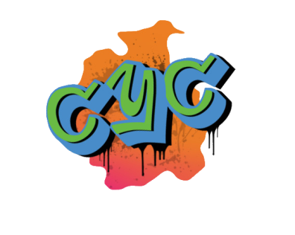

Cumbria
Youth Commission
on Police and Crime
2017/18:
Application Form

Do you live in Cumbria? Are you between the ages of 14 and 25? Would you like to have your say on policing and crime in Cumbria?

Cumbria Youth Commission is currently looking for applicants.

What is Cumbria Youth Commission?

The Cumbria Youth Commission was established in April 2017 using funding from the Police and Crime Commissioner for Cumbria.
This project aims to enable young people aged 14-25 to inform decisions about policing and crime prevention in Cumbria, working in partnership with the Police and Crime Commissioner and Cumbria Police.

This is a unique opportunity for you address the issues that are most important to you, whilst producing and developing solutions that will help young people across the county.

But what’s in it for you? In addition to the satisfaction of helping young people in your local area, Cumbria Youth Commission will also;

Help you develop your; interpersonal skills, research skills, peer education skills etc.

Look fantastic on your CV

Give you the opportunity to travel across Cumbria and to other parts of the UK.

If you are interested in being part of Cumbria Youth Commission, please complete the attached application form.

SECTION 1: YOUR DETAILS

NAME:
DATE OF BIRTH:
OCCUPATION: (Student,
in work, unemployed etc.)
NAME OF YOUR SCHOOL, COLLEGE, YOUTH ORG.
HOME ADDRESS:
POST CODE:
EMAIL:
MOBILE/LANDLINE:

If you are selected, we would like to be able to connect/contact you via social media. Please provide your social media handles below:

FACEBOOK | www.facebook.com/
TWITTER: | @

If you are under 18 years old, please ask your parent/guardian/carer to provide the following details. We will require written permission from them before we can confirm your place.

NAME:
HOME ADDRESS:
POST CODE:
EMAIL:
MOBILE/LANDLINE:

SECTION 2: MORE ABOUT YOU

WHY DO YOU WANT TO JOIN THE YOUTH COMMISSION? Please briefly describe why you would like to be part of Cumbria Youth Commission.

SECTION 3: YOUR COMMITMENT

Being part of Cumbria Youth Commission requires a certain level of commitment from those involved. As a Youth Commissioner, you will be expected to;
- Attend regular meetings in your area
- Complete a small amount of independent work in between meetings
- Attend trips, residentials and external meetings relating to the Youth Commission, some of which will take place on weekends and during school holidays

Yes, I am able to commit to the above:

No, I am unable to commit to the above
but would still like to take part in some
other way:

Signed: Date:

Please email completed application forms to Rachel and Ian on: youthcommission@youngcumbria.org.uk. You will be contacted witin 2 weeks of submission. Hard copies of application forms can be posted to: Units 4 & 5 Moss Bay House, Peart Road, Derwent Howe, Workington, CA14 3YT. For more information, please call: 07823412094 (Rachel) or 07823 528 711(Ian).

