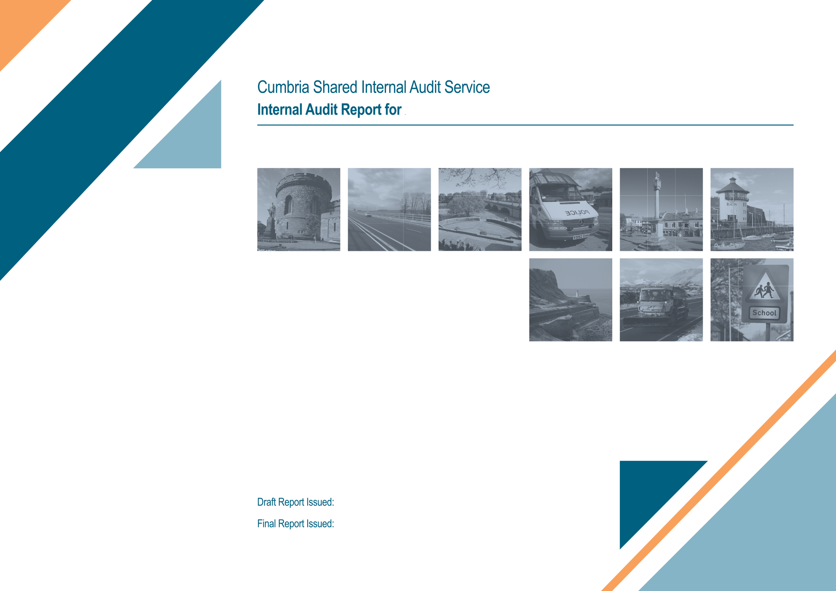

Cumbria Constabulary & OPCC

Audit of Payroll
7th April 2017
9th March 2017

Audit Resources

Title | Name | Email | Telephone
Audit Manager | Emma Toyne | emma.toyne@cumbria.gov.uk | 01228 226254
Lead Auditor | David Kendrick | david.kendrick@cumbria.gov.uk | 01228 226255

Audit Report Distribution
For Action: | Alison Hunter, Payroll and Transactional Services Manager
For Information: | Ann Dobinson, Head of Central Services  Stephen Kirkpatrick, Director of Corporate Support  Roger Marshall, Chief Finance Officer.
Audit Committee | The Joint Audit Standards Committee, which is due to be held on 24th May 2017, will receive the report.

Note: Audit reports should not be circulated wider than the above distribution without the consent of the Audit Manager.

- Background

  - This report summarises the findings from the audit of the Cumbria Constabulary and Office of the Police Crime Commissioner’s (OPCC) payroll which was undertaken in accordance with the 2016/17 Audit Plan.

  - Payroll is a key process administered by the Central Services department of Cumbria Constabulary. The salaries of approximately 1900 Constabulary and 25 OPCC employees are paid through the system.

- Audit Approach

2.1 Audit Objectives and Methodology

    - Compliance with the mandatory Public Sector Internal Audit Standards requires that internal audit activity evaluates the exposures to risks relating to the organisation’s governance, operations and information systems. A risk based audit approach has been applied which aligns to the five key audit control objectives which are outlined in section 4 of this report; detailed findings and recommendations are reported within section 5 of this report.

  - Audit Scope and Limitations

2.2.1 The Audit Scope was agreed with management prior to the commencement of this audit review. The Client Sponsor for this review was the Director of Corporate Support and the agreed scope was to provide independent assurance over management’s arrangements for ensuring effective governance, risk management and internal controls in the following areas:
- Procedures
- Security
- Payroll data.

2.2.2 There were no instances whereby the audit work undertaken was impaired by the availability of information.

- Assurance Opinion

  - Each audit review is given an assurance opinion and these are intended to assist Members and Officers in their assessment of the overall level of control and potential impact of any identified system weaknesses. There are 4 levels of assurance opinion which may be applied. The definition for each level is explained in Appendix A.

  - From the areas examined and tested as part of this audit review, we consider the current controls operating in respect of payroll provide Substantial assurance.

Note: as audit work is restricted by the areas identified in the Audit Scope and is primarily sample based, full coverage of the system and complete assurance cannot be given to an audit area.

- Summary of Recommendations, Audit Findings and Report Distribution

  - There are three levels of audit recommendation; the definition for each level is explained in Appendix B.

  - There are no audit recommendations arising from this review.

4.3 Strengths: The following areas of good practice were identified during the course of the audit:

- Existence of clearly stated targets which are fully and consistently achieved thereby supporting effective and efficient service delivery.
- Regular monitoring and reporting of payroll performance to senior management.
- Fully implemented, purpose built payroll system supported by comprehensive procedures and bespoke training.
- A good level of training for staff involved in payroll processes with detailed documented procedures in place.
- Robust access controls to the system contributing to the integrity of payroll data.
- Up to date registration with the Information Commissioner for data protection purposes.
- In-built data validation routines within the system ensuring data is bona-fide, accurate and complete.
- Detailed management review of input and reconciliation routines, including deductions prior to payment.
- Strict adherence to timetables for payroll and the transfer of statutory deductions.

Comment from the Director of Corporate Support:
I am delighted that this review of the Payroll function has provided Substantial assurance and that there are no areas for action identified. The audit has confirmed that the Constabulary has an excellent approach to the provision of Payroll services which effectively supports and enables the organisation to provide robust, reliable and effective remuneration for all employees. The audit identified numerous areas of good practice without identifying any areas for development, which is a credit to all staff involved in the Payroll function.

I am pleased that the audit highlighted the strong governance and oversight of the procedures and systems in place. The Central Services Department maintains a strict focus on Payroll to ensure both a reliable ongoing business as usual service and, crucially, to ensure that the service continues to improve wherever possible. These findings are extremely positive in recognising the excellent work undertaken regarding Payroll services, specifically within the Central Services Department.

Audit Assurance Opinions

There are four levels of assurance used; these are defined as follows:

Grading of Audit Recommendations
 | Definition: | Rating Reason
Substantial | There is a sound system of internal control designed to achieve the system objectives and this minimises risk. | The controls tested are being consistently applied and no weaknesses were identified.  Recommendations, if any, are of an advisory nature in context of the systems and operating controls & management of risks.
Reasonable | There is a reasonable system of internal control in place which should ensure that system objectives are generally achieved, but some issues have been raised which may result in a degree of risk exposure beyond that which is considered acceptable. | Generally good systems of internal control are found to be in place but there are some areas where controls are not effectively applied and/or not sufficiently developed.  Recommendations are no greater than medium priority.
Partial | The system of internal control designed to achieve the system objectives is not sufficient. Some areas are satisfactory but there are an unacceptable number of weaknesses which have been identified and the level of non-compliance and / or weaknesses in the system of internal control puts the system objectives at risk. | There is an unsatisfactory level of internal control in place as controls are not being operated effectively and consistently; this is likely to be evidenced by a significant level of error being identified.  Recommendations may include high and medium priority matters for address.
Limited / None | Fundamental weaknesses have been identified in the system of internal control resulting in the control environment being unacceptably weak and this exposes the system objectives to an unacceptable level of risk. | Significant non-compliance with basic controls which leaves the system open to error and/or abuse.  Control is generally weak/does not exist. Recommendations will include high priority matters for address. Some medium priority matters may also be present.

Audit recommendations are graded in terms of their priority and risk exposure if the issue identified was to remain unaddressed. There are three levels of audit recommendations used; high, medium and advisory, the definitions of which are explained below.

 |  | Definition:
High | ● | Significant risk exposure identified arising from a fundamental weakness in the system of internal control
Medium | ● | Some risk exposure identified from a weakness in the system of internal control
Advisory | ● | Minor risk exposure / suggested improvement to enhance the system of control

Recommendation Follow Up Arrangements:
- High priority recommendations will be formally followed up by Internal Audit and reported within the defined follow up timescales. This follow up work may include additional audit verification and testing to ensure the agreed actions have been effectively implemented.
- Medium priority recommendations will be followed with the responsible officer within the defined timescales.
- Advisory issues are for management consideration.

