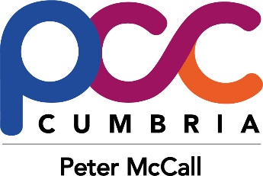

Staff of the Police & Crime Commissioner

1. Statutory instrument 3050 (Elected Local Policing Bodies (Specified Information) Order 2011) states that all Offices of Police and Crime Commissioners must publish certain information about their staffing structure.

2. There are currently 9 full time members of staff in the Office of the Police and Crime Commissioner for Cumbria (COPCC). A copy of the staff structure is available on the Commissioner’s website in the section Peter McCall and my team.

3. The gender breakdown of the OPCC is 90% female and 10% male.

4. All staff members declare their ethnic background to be White –British.

5. No staff members have declared that they consider themselves to have a disability.

6. This information is up to date and accurate as of 30 September 2017. The information contained above is reviewed on an annual basis and any amendments published immediately.

