



Victims Needs Assessment

The Office of Police and Crime Commissioner

Police Headquarters

Carleton Hall

Penrith

Cumbria, CA10 2AU

Table of Contents

Introduction 2

Background and strategic context: 2

What have we done since the last review? 3

Methodology: 7

Demographics of Cumbria 7

Deprivation: 7

WHAT DO WE KNOW ABOUT OUR VICTIMS? 8

All victim-based crime: 8

Complexity 9

Mental Health 10

Drugs and Alcohol 12

Unity Drug and Alcohol Services Data: 13

New Psychoactive Substances(NPS): 14

Homelessness 14

Missing Persons: 16

Hate Crime 16

Domestic Abuse 18

Let Go Data: 19

IDSVA Data: 20

Freedom Data: 22

Harassment and Stalking 22

Sexual Violence 24

So called Honour Based Violence, Forced Marriage and Female Genital Mutilation 25

Trafficking, Child Sexual Abuse and Sexual Exploitation 25

Cyber Crime 30

Acquisitive Crime 30

Business Crime 30

Rural Crime 30

Non-domestic burglary 32

Anti-Social Behaviour 32

Anti-social Behaviour Strands: 33

Alcohol Level as a contributing factor: 34

Analysis of Qualitative Questionnaire – ASB 34

Road Safety: Killed and Seriously Injured (KSI) Statistics 35

The Case for Change – 36

# Introduction

## Background and strategic context:

**The Victim’s Code**

Since the reports “Taking the Next Step” and “Care Consideration and a Voice for Victims” of (2012/2013), the Victim’s Code was introduced by the Ministry of Justice (MOJ) in October 2013.

The Victims’ Code governs services to be provided to victims of crime by criminal justice agencies in England and Wales (see annexe 1) and forms a key part of the wider Government strategy to transform the criminal justice system by putting victims first, making the system more responsive and easier to navigate.

The Commissioning Framework provided by the MOJ focuses on outcome based commissioning which is far more effective for achieving the overarching aims of supporting victims to **cope** with the immediate impacts of crime and **recover** from the harm experienced.

The new commissioning process in England and Wales forms part of a strategic move towards more personalised services for local people and investment in the voluntary and community sector. As part of this process, since 2014, we have moved to a model where the majority of emotional and practical support services for victims of crime are commissioned locally by Police and Crime Commissioners (PCCs). At a national level the Ministry of Justice commission a witness service, a homicide service, support for victims of human trafficking, support for victims of rape through rape support centres, some victims’ national telephone help-lines and some other support for victims of domestic and sexual violence.

Successful commissioning is not simply based on how to best optimise the use of money. It encompasses a full range of resources, many different ways of improving outcomes, partnership working and assessing a range of services available to secure better outcomes as well as securing value for money.

New legislation also enable PCCs to provide or commission services for victims, witnesses and others affected by anti-social behaviour not directly caused by a criminal offence. However, the funding issued by the Ministry of Justice under s.56 of the DVCVA cannot be used for this purpose.

The EU Directive establishing minimum standards on the rights, support and protection of victims of crime has been adopted and those standards were implemented into the Victim’s Code in November 2015.

Victims of crime should be treated in a respectful, sensitive, tailored and professional manner without discrimination of any kind. They should receive appropriate support to help them, as far as possible, to cope and recover and be protected from re‑victimisation. It is important that victims of crime know what information and support is available to them from reporting a crime onwards and who to request help from if they are not getting it.

The Code sets a minimum standard for these services. Service providers can choose to offer additional services and victims can choose to receive services tailored to their individual needs that fall below the minimum standard.

For the purposes of this Code, a “victim” is:

• A natural person who has suffered harm, including physical, mental or emotional harm or economic loss which was directly caused by a criminal offence.

• A close relative of a person whose death was directly caused by a criminal offence.

Legal persons (e.g. businesses) are not included within the definition of a victim. Businesses are only entitled to services under this Code in accordance with Chapter 4.

Enhanced entitlements are provided to victims of the most serious crime, persistently targeted victims and vulnerable or intimidated victims.

For further information on the Victims' Code:  <https://www.gov.uk/government/publications/the-code-of-practice-for-victims-of-crime>

This report reflects and continues the mapping exercise of the landscape for victims of crime and anti-social behaviour in Cumbria. The purpose of this document is to outline progress since the previous reports, identify current gaps in victim service provision and emerging themes, and provide an evidence base for future commissioning.

|  |
| --- |
| Recommendation: Agencies keep victims central to their business and where possible tailor services to the need of the victim. |
| Recommendation 1: Services provided to victims should be driven by need not crime type, and firmly aligned with the requirements of the Victim’s Code. |
| Recommendation 2: Locally commissioned services must be able to operate across geographical PCC boundaries. |
| Recommendation 3: Better coordination of services involved with/provided to victims through a Victims Hub |

## What have we done since the last review?

Following on from the recommendations of the previous reviews and in line with his commitment to keeping victims safe and at the heart of the Criminal Justice system, Cumbria’s Police and Crime Commissioner has;

* Provided funding for **CCTV** county-wide.
* Funded Independent **Domestic and Sexual Violence Advisors** (IDSVA’s) in hospitals.
* Established a **Victim Care Unit** in Cumbria to ensure a more efficient and effective referral service for victims in Cumbria.
* Provided funding for the **Cumbria Restorative Services Hub** allowing victims to engage in Restorative Justice Practices.
* Funded **“Chelsea’s Choice”**, a production for children raising awareness of Child Sexual Exploitation (CSE).
* Formed a **Consultation Group** made up of individuals who have all been victims of crime or antisocial behaviour, to assist in auditing and developing services to those affected by crime and Anti-social Behaviour.
* Funding the county wide IDVA **(Independent Domestic Violence Advisor)** service in partnership with the County Council.
* Commissioning **Victim Support** to provide emotional, practical, advocacy and signposting services.
* Funded **Hate Crime Awareness workshops** around the county.
* Funded a support service for victims and witnesses attending **Coroner’s Courts**.
* Introduced **“Cumbria Victims Charitable Trust”** to generate additional income to supplement the funding provided by the Ministry of Justice for victims and expand services to assist in supporting the needs of victims of crime and antisocial behaviour.
* The introduction of the **Bridgeway Sexual Assault Support Services** which includes forensic examination and other health services, emotional support and counselling will be available in Cumbria for all victims of sexual assault, whether reported or not.
* Commission a county-wide ISVA (Independent Sexual Violence Advisor) service.

[www.thebridgeway.org.uk](http://www.thebridgeway.org.uk)

* Introduced county wide Perpetrator Programmes **“Turning the Spotlight”** in respect of domestic abuse in adolescent relationships, where domestic abuse is occurring between children and their parents and with a holistic approach working with whole families.
* 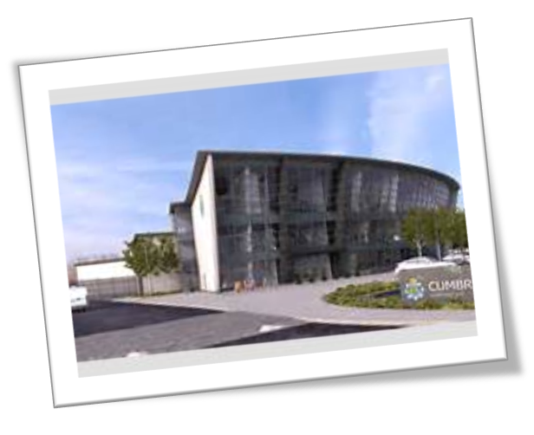Introduced a county-wide Perpetrator Programme addressing **Hate Crime.**
* Funded a local group to deliver the **‘Risky Business’** educational programme to young people county wide, to establish a Youth Commission and produce a report on the programme.
* Funded a **Hate Crime production** for children, raising awareness of the issues and impact of such crimes in respect of all strands of diversity.
* Funded the **“Know Your Criminal Justice”** events across the county for people with learning difficulties.
* Funded the **“TURNING” DVD** and training resource in respect of Domestic Abuse within adolescent relationships. This will be a county-wide available resource for a wide range of school audiences and attendance centres.

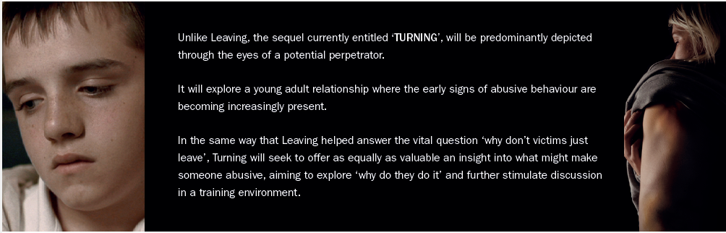

* 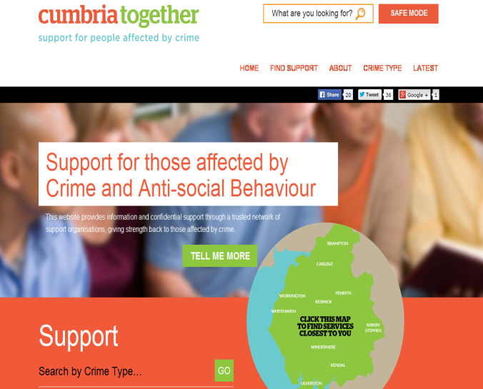The **Cumbria Together website** [www.CumbriaTogether.com](http://www.CumbriaTogether.com) has been developed with the purpose of providing an Information Portal bringing services and information about what is available for those affected by crime together irrespective of whether the crime has been reported or not to statutory agencies.
* Re-introduced a **Victims and Witnesses group** to drive up standards of customer service to victims and witnesses, and increase their satisfaction and confidence in the criminal justice system.
* Formed a **Consultation Group** made up of individuals who have all been victims of crime and assist in auditing and developing services to those affected by crime and anti-social behaviour.
* In collaboration with the Constabulary, the Police and Crime Commissioner is currently looking to establish a **single point of contact** to support county wide community cohesion and engagement with vulnerable communities and all strands of diversity and equality.
* Commissioned a service **‘Keep Safe’** to develop county wide target hardening services across Cumbria for victims of crime and anti-social behaviour.
* Funded **“Brake”** specialist support for bereaved families of victims killed as a result of Road Traffic Accidents.
* Funded **Deaf Vision** to have parts of the Constabulary website signed by a deaf interpreter.
* The Commissioner’s Innovation, Community and Property Funds also continue to provide financial support for numerous projects working with victims across Cumbria. [Community Fund](http://www.cumbria-pcc.gov.uk/working-for-you/community-fund.aspx), [Innovation Fund](http://www.cumbria-pcc.gov.uk/working-for-you/innovation-fund.aspx) and [Property Fund](http://www.cumbria-pcc.gov.uk/working-for-you/property-fund.aspx).

**Case Study –Role of the IDSVA**

Case discussed at MARAC in July 2015 which was also a repeat case. Victim is a drug addict and has alcohol and mental health issues. She is also a known prostitute and has numerous convictions. She has involvement with numerous agencies who have serious concern regarding her being the victim of Domestic Violence. She does not report DV incidents nor provide statements of complaint to police.

The Perpetrator is known on the local drug scene to use and deal. He has numerous convictions including offences against the person, firearm offences and robbery. He is currently on licence from prison.

Both lead a chaotic lifestyle and the victim is renowned for not keeping appointments with agencies.

‘Let Go’ have been trying to assist the victim for a period of time and arrangements were in place for the victim to meet with Let go and officers from Public Protection Unit whilst at a Unity appointment, in order to take her to a refuge away from the area. The victim did not keep the appointment. Agencies remained concerned for her welfare.

On 21st August the IDSVA received a telephone call from Unity advising that the victim’s mother had contacted to advise that the victim would not be able to keep her appointment as she had been badly beaten by her partner and was intending to attend A & E to have her injuries treated.

Unity made contact with Let Go who advised that the victim’s key worker was on holiday and suggested that Unity make contact with hospital IDSVA.

Unity made contact with hospital IDSVA and passed on the information and asked for victim to be seen by IDSVA if she attended A & E. The IDSVA made contact with A & E reception and asked to be contacted ASAP should the victim attend.

Several hours later the IDSVA received a call from A & E to advise that the victim was in the department, thereafter she attended to speak with the victim. The victim had extensive bruising to her head and body following a brutal and sustained attack by the perpetrator which had taken place the night before. There was concern that she had potentially lost consciousness at some point during the attack therefore arrangements were made for her to have a head scan.

Initially the victim was adamant that she did not want the police informed. The importance of obtaining the victim’s consent to contact the police was deemed crucial by the IDSVA as her co-operation to willingly provide a statement was needed to secure the arrest of the perpetrator.

The IDSVA discussed the incident with the victim and the dynamics of the abuse, along with her options. This was done in a manner that took into account the need for the victim to remain in hospital for the duration required to deal with her injuries.

Following discussion, consent was given and IDSVA contacted the police on behalf of the victim. Whilst awaiting the arrival of the police the victim moved between being calm then stressed and threatened to leave on several occasions. The IDSVA was aware due to the history that if she left the department then it would be unlikely that she would later engage with the police and provide a statement. Reassurance was given to the victim throughout. She was medically discharged and the police attended.

The Police took the victim to an address of her choice to obtain a statement from her. The perpetrator was arrested and upon conclusion of police enquiries he was charged with:

ABH x 2, False Imprisonment, Malicious Communication and an assault on another person.

The Perpetrator appeared in court and his licence was revoked and he was returned to prison.

## Methodology:

The assessment is based on the analysis of quantitative and qualitative data collated from a range of partner agencies and consultation directly with victims. Raw data has also been provided by Cumbria Constabulary for a 3-year period [April 12 to March 15].

The report also draws on relevant data, literature and research conducted both locally and nationally into the nature of victimisation, and the needs of different groups of victims. Information from local needs assessments and problem profiles were used to evaluate, identify and evidence victim’s needs and offending behaviour in our county.

## Demographics of Cumbria

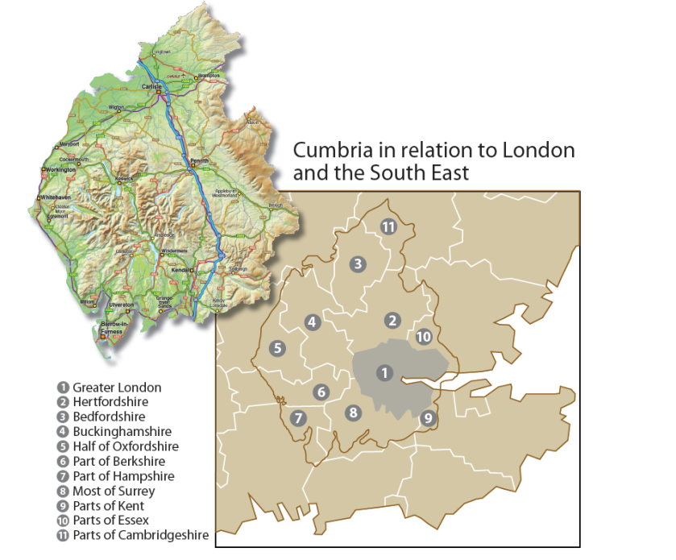The demographics of Cumbria have not changed greatly since the last report. Cumbria is the second largest county in England with a population of 497,900 mid-2014; the population increased by 6,700 between 2003 and 2014. An estimated 42,000 veterans of the Armed Forces reside in Cumbria. Over 50% of the population live in rural communities spread across the county, compared to 18% nationally. This brings diverse and unique challenges for partners and authorities in delivery of services ensuring accessibility to all, especially those in the most remote and isolated communities.

## Deprivation:

Cumbria Community Safety Strategic Assessment and the Indices of Multiple Deprivation states Cumbria has 29 communities that rank within the 10% most deprived of areas in England with 8.3% of the county’s populating living in 29 of these communities. Furthermore 8 of Cumbria’s communities are classified as being within the 3% most deprived nationally. Barrow-in-Furness has thirteen communities that are ranked within the 10% most deprived areas in England in overall deprivation. Allerdale has six communities ranked within the 10% most deprived of areas in England. Copeland has five communities that rank within the 10% most deprived of areas in England and Carlisle has five communities that rank within the 10% most deprived of areas in England[1]

|  |  |  |  |
| --- | --- | --- | --- |
|  | Land Area (KM2) | Resident Population mid-2014 | Population Density (persons per KM2) |
| England & Wales | 151,012 | 56,948,200 | 377 |
| Cumbria | 6,767 | 498,900 | 74 |
| Allerdale | 1,242 | 96,200 | 77 |
| Barrow-in-Furness | 78 | 67,800 | 870 |
| Carlisle | 1,039 | 107,900 | 104 |
| Copeland | 732 | 70,000 | 96 |
| Eden | 2,142 | 52,600 | 25 |
| South Lakeland | 1,534 | 103,500 | 67 |

*Source: JSNA Population – January 2015*

# WHAT DO WE KNOW ABOUT OUR VICTIMS?

## All victim-based crime:

During the period of April 2014 to March 2015 victim-based crime increased by 2% from 20,760 to 21,150 from the same period the previous year. During the same period incidents of anti-social behaviour decreased from 23,856 to 20,208 a decrease of -15%. [2]

* Violence against the person offences during this period increased by 25% from 5238 to 6556;
* Sexual Offences increased by 68% from 415 to 696 [Rape offences increasing by 62% and Other sexual offences by 70% in the same period];
* Hate crimes also increased by 37% from 246 to 337;
* Public Order offences increased by 45% from 1090 to 1583, many of these offences are linked to night-time economy and alcohol abuse;
* North and South Cumbria continue to have the highest number of domestic burglaries;
* All other offences such as theft, criminal damage and anti-social behaviour saw a decrease when compared to the previous reporting period;

Increases in recorded crime were found across all Cumbria’s districts in 2014/15. Sexual Offences increased by +65.3% an increase of 277, Violence against the person by +24.7% or 1,298 and alcohol related crime increased by +13.7% or 427 when compared to the previous year. Carlisle had the highest number of crimes whilst Barrow had the highest rate of offences per 1,000 population. The lowest number of crimes were recorded in Eden, although the district showing the lowest rate of offences per 1,000 population is South Lakeland.[3] Improved compliance with crime recording standards and the introduction by the Home Office of new offence codes is likely to have contributed to the increased figures[4].

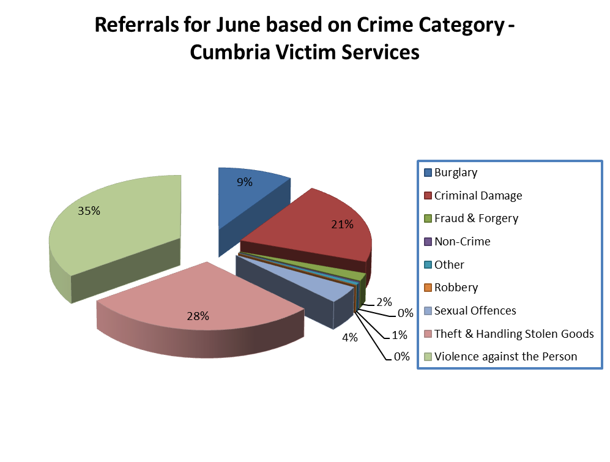The total number of referrals to victim support for 2014/15 equated to 23,019, 11,004 related to referrals whereby the victim had either not given consent for victim services to contact them or on initial contact had declined support. The remainder of referrals 12,015 were offered and accepted support services. This equates to victim services working with 57% of victims:

Violence against the person amounted to 34% {3844} of the overall referrals, theft and handling stolen goods equated to 29% or 3440 and criminal damage accounted for 23.9% or 2883 of the overall total number of referrals. [5]

* 48% were female compared to 44% males.
* 25 to 34 yrs. accounted for 22% of the overall total of referrals, 35 to 44 yrs. equated to 17% and 18 to 24 yrs. to 16%, 17yrs and under accounted to 12% and 55+ equated to just 17% of the overall total.

The data provided by victim services evidences crime data when comparing age groups, gender and increases in crime categories, such as violence against the person. [6]

## Complexity

In addition to being a victim of crime, a large number of our victims have the complexity of drugs, alcohol and mental health issues. In some cases, these issues are associated with becoming or being a long term victim. In other cases individuals are vulnerable because of these issues and become an easy target for victimisation.

**a) Repeat Victimisation:**

Repeat victimisation can be scary and debilitating for victims. Whilst crime data for the period April 2014-March 2015 was analysed to determine repeat victimisation, this alone will not give a full picture of repeat victimisation per age group and area as the data is based on repeat victim’s markers being applied to the crime at the time of recording.

**b) Most Prolific Age Groups per Gender:**

* Highest age group for males with repeat victimisation are between 36 to 55 years,
* In females 18 to 35 years represent 51.2% of the overall figure, with 36 to 55 years accounting for 34.7%. [7]

**c) Multiple Vulnerability Victims:**

The Constabulary’s definition of a vulnerable adult is;

A person 18 years or over and who is or may be in need of community care services by reason of mental or other disability, age or illness: and who is or may be unable to take care of him or herself, or unable to protect him or herself against significant harm or exploitation.

The Constabulary submitted 4415 Vulnerable Adult (VA) reports between April 14 and Mar 15.

VA reports are submitted by officers with a concern for any adult they deem vulnerable, these aren’t necessarily victims of crime (most aren’t), nor do they necessarily have a mental health issue, it’s very much the perception of the officer who attended and mental health may be the closest category they choose (often it’s alcohol abuse)

The figures above do not reveal repeats, so where a person with dementia for example is repeatedly found wandering the streets a VA would be submitted each time, obviously they aren’t a victim of crime and they may appear on the system several times.

This method is problematic and reliant on risk markers being accurately applied to crimes. There is also the problem of identifying vulnerabilities as often there is no indication or evidence of alcohol or drug abuse, in many cases mental health problems remain undiagnosed and often there are no obvious signs or behaviours at the time of contact, anxiety, depression and mental health problems can present at a later date either as a result of individual constructs, other causation factors that increase vulnerability or on-going exposure to domestic violence and other targeted crimes.

|  |
| --- |
| **Recommendation 4: Consider the recommendations for change as suggested in the HMIC Vulnerability Report.** |

## Mental Health

A recent study conducted by Kings College London and Victim Support ‘At Risk, Yet Dismissed’ highlighted that 45% of people with severe mental illness were victims of crime in the past year; 18% of an assault. 40 to 60% of women with severe mental illness reported being the victim of domestic or sexual violence since age 16 and 10-16% in the past year. People with mental health problems are very vulnerable to repeat victimisation, of different types of crime. 43% experienced more than one type of crime in the past year.

There are significant mental health issues in Cumbria. The overall impact of suicide and injuries undetermined on the residents of Cumbria is high with a premature mortality rate of 9.1 compared to 7.9 for England. [8]

* In 2011-13 the rate of suicide in Cumbria was 10.9 per 100,000 compared to 8.8 per 100,000 in England. Nationally the rate is higher in males this is reflected in Cumbria with a suicide rate of 17.9 per 100,000 compared to 13.8 in England [9]
* 36 to 55 years present as the highest age, of the overall male and female victims with mental health markers attached.
* 23,900 of the 110,000 children under 20yrs in Cumbria have “Common Mental Health Issues” .Hospital admission for unintentional and deliberate injuries, ages 0.24 per 10,000 population is significantly higher in Cumbria [135.1] compared to England [116.0]

Hospital Admissions per Area:

* Barrow is above the national average at 387.4 per 100,000 for hospital admissions for deliberate self-harm. Carlisle 331.3, Copeland 298.7 and South Lakeland is 205.9. Eden is below the national average at 110.5.[10]

Cumbria Joint Strategic Needs Assessment Summary Report 2010 identified under investment in mental health commissioning, inefficiencies in service provision, gaps and inequities in the distribution and delivery of, and access to services and that investment could lead to savings in the health system and beyond. The Joint Strategic Needs Assessment is currently under review and the reporting structure has changed meaning that information and data relating to mental health issues will not be available until Quarter 2 of 2017.

When reviewing the current Cumbria Health Profile based on data for 2012/13 there appears to be a considerable gap in service provision compared to the level of mental illness for the county. Whilst prevalence of mental illness appear significantly higher than the England average, in contradiction the level of comprehensive care plans, % of service users and nursing or residential care appears significantly lower than the England average.

|  |
| --- |
| There were 128 Section 136’s in Cumbria from April to September 2014. Of these, 33 went to the police station first and 95 to the hospital. There was x 1 under 18 detained in police cells and x4 under 18s in hospital. |
| Police call handling data shows that on average they are receiving between 30 and 40 identified calls per day for service that can be attributable to people with mental health problems. These are indicative numbers only as on-going qualitative audits identifies that the number of calls is up to 60% higher. | |

There are clearly issues around the use of police stations for individuals with Mental Health problems.

|  |
| --- |
| Recommendation 5: Crisis Care Concordat to proactively engage partners in improving service to victims of crime. |
| Recommendation 6: Explore a Mental Health Triage model to understand best fit for urban and rural settings. |
| Recommendation 7: Consider the recommendations from the “At Risk yet Dismissed” report. |

|  |
| --- |
| **Recommendation 8:** **Constabulary to establish robust flagging and tagging processes for victims of the most serious crime; persistently targeted victims; and vulnerable or intimidated victims and ensure measures to capture this are included into the development of Red Sigma (Case Management System).** |

## Drugs and Alcohol

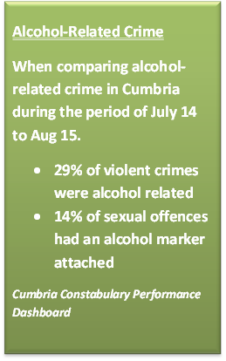The National Probation Service suggests that between 50 and 80% of assault, murder and rape cases, alcohol has been a contributing factor. Current research carried out by the Office of National Crime Statistics indicates that in a community of 100,000, 1,000 people will be a victim of alcohol-related violent crime. The Home Affairs Committee has highlighted their concern around the increase in deaths last year associated with new psychoactive substances; deaths in the UK have increased by 79% in the last year.[11]When comparing Cumbria police data for the period July 2014 to August 2015 with the same period last year there has been a 20% reduction in drug offences[12]. However this could be largely due to the introduction of New Psychoactive Substances the impact and level of which is significantly under-recorded, although there is no evidence to suggest a shift in drug behaviours with users in Cumbria. Reductions in crime statistics should be treated objectively and with caution.

Alcohol specific hospital admissions for Cumbria (all persons, all ages) are worse than the average for England. For young people aged under 18 years, alcohol specific hospital admissions are worse than the regional and England averages.[13]

* In 2012/13 alcohol related admissions to hospital in Cumbria were significantly higher than in England for both males and females, 706 per 100,000 compared to 637 per 100,000.
* Hospital admissions for under 18 alcohol consumption are higher than the national average of 40.1. Allerdale (73.8), Barrow (93.6), Copeland (105.8) and South Lakeland (78.8) have rates higher than the national average with Copeland having the highest rate. [14]

### Unity Drug and Alcohol Services Data:

Throughout 2014/15 there were 3,118 service users in contact with Unity, a decrease of -3.8%. Most service users (57.7%) use the service for drugs related issues; 42.3% use the service for alcohol related issues. 65.7% of all service users are male; 34.3% female. The majority of all service users (64.0%) are aged between 30 to 49. Heroin is the main drug use of service users across all districts. 6,000 people have registered for needle exchange with the majority of users reporting performance enhancers as their main drugs.[15]

Data provided by Unity Drug and Alcohol services for period April 14 to March 15 evidenced that;

***Alcohol accounted for the highest referral reason, equating for 58% of the overall* referrals, Drugs accounted for 40.5%.**

|  |  |
| --- | --- |
| Referral Reason | Count |
| Treatment – Alcohol | 2422 |
| Treatment – Drugs | 1692 |
| Treatment – Non-Opiates | 1 |
| Treatment – Opiates | 59 |
| Grand Total | 4174 |

**Self-referrals accounted for 44.4% of the overall total of referrals, GP’s equated to 18.3%, Prisons 11.1%, Probation 2.7% and Community MH teams 2.6%**

|  |  |  |  |  |  |  |  |  |  |  |  |  |  |  |  |  |  |  |  |
| --- | --- | --- | --- | --- | --- | --- | --- | --- | --- | --- | --- | --- | --- | --- | --- | --- | --- | --- | --- |
| |  |  | | --- | --- | | Age Band |  | | 18-25 | 498 | | 26-35 | 1272 | | 36-45 | 1197 | | 46-55 | 776 | | 56-65 | 318 | | 66+ | 108 | | Null | 5 | | Total | 4174 | |  |

**The highest age group for referrals were 26 to 35yrs equating to 30.4%, 36 to 45 yrs. accounted for 28.6% of the overall referrals.**

|  |  |
| --- | --- |
| Gender | Count |
| Female | 1289 |
| Male | 2885 |
| Total | 4174 |

**Males accounted for 69.1% compared to females who equated to 30.8% of the overall total referrals**

|  |  |
| --- | --- |
| Region | Count |
| Barrow | 991 |
| Carlisle | 1083 |
| Kendal | 361 |
| Penrith | 289 |
| Whitehaven | 613 |
| Workington | 837 |
| Total | 4174 |

### New Psychoactive Substances (NPS):

The total number of NPS recorded incidents on Cumbria Police records since 2012 equated to 99, with 39 of these incidents occurring in 2015.

Data shows that the majority of individuals taking these substances are between the age of 15 to 29 (with one as young as 9yrs), 28 being males, 4 females and 7 unknown (gender unrecorded) Barrow has remained the highest recorded town for NPS usage. [16]

## Homelessness

Whilst we have no clear evidence of the scale of homelessness across Cumbria and not all homeless individuals are victims of crime, they can be vulnerable and more susceptible to victimisation or resort to offending behaviour. We are aware that a number of individuals in our community are “sofa surfing”, this may be because they are fleeing domestic abuse, have been evicted, because they have no money or simply because they have no other option available to them at the time. At the recent meeting of the (3rd sector) homeless support group, knowledge of current provision (particularly food) in Carlisle for homeless people was discussed. It was agreed that it would be useful for all the local churches to know what is available, as frequently the church door is the first place the needy will call for assistance. It is clear from the information provided (see Annexe 4) that depravation is an issue in Cumbria and that, again the 3rd sector play a vital role in addressing some of the issues associated with it.

* **Cumbria had a total of 63 applicant households with dependent children or pregnant women accepted as unintentionally homeless and eligible for assistance in the last year, this equated to 0.3 per 1,000 compared to 1.7 per 1000 households nationally.**
* **In the last year 147 contacts have been made through Cumbria’s Safeguarding Hub for 16-17 years olds presenting as homeless.**

The Cinnamon Faith Action Audit (May 2015) found that there were already developing partnerships between Faith Groups and the Local Authority, Police and other agencies but that more could be done to create a collaborative approach. The types of needs addressed includes helping people with addiction, people trapped in trafficking or prostitution, supporting people in financial crisis, alleviating homelessness, helping refugees and asylum seekers, supporting families and reducing social isolation. Activities being offered included accommodation, debt advice and support, foodbanks, services for the disabled, night shelter, provision of meals, befriending, mentoring and healthcare.

A good example of assistance with regard to this issue during the night-time economy in North Cumbria is the Carlisle Street Pastors. A charitable organisation, supported by the Police, City Council and local churches the Pastors are identified as being a re-assuring presence and calming influence in the city of Carlisle on Saturday nights. Looking after peoples’ welfare, especially during the early hours when alcohol can leave people especially vulnerable. The Pastors role however has extended far beyond that. Police patrols can now contact the Pastors to assist the vulnerable and the Pastors themselves are alert to safety issues and have removed sometimes as many as 64 glasses and bottles in one evening, from potentially dangerous locations within the city centre. This has undoubtedly prevented these being used as weapons or causing accidental injury.

The Pub Watch scheme is another useful tool to avoid unnecessary confrontation and difficulties associated with alcohol. This scheme is operated by the licencing body which is not fully understood by victims. No-one appears to have responsibility of letting the victim know that the perpetrator is subject to Pub Watch. It also to some degree relies on the victim letting the landlord know if the perpetrator is on the premises when they shouldn’t be.

|  |
| --- |
| Recommendation 9: Coordination and management of Pub Watch need to make information about the scheme more accessible to victims and to let victims know if the perpetrator in their case has been included on the Pub Watch scheme, for how long and details of the area covered by the banning notice. |
| Recommendation 10: Many club users do not see traditional drug services as meeting their needs. Services need to work to change this attitude by making the needs of club drug and NPS users ‘core business’ and placing them on an equal footing with alcohol and opiate treatment. |

|  |
| --- |
| Recommendation 11: Increase training for healthcare staff, police and other emergency services who do not have sufficient knowledge or skills to manage harm related to club drug and NPS use (this should include sexual health clinics) |
| Recommendation 12: Patterns of use and the harmful effects of these drugs rapidly change; therefore data on the harm from NPS and club drugs should be recorded not only from drug and alcohol services, but also mental health, police, accident and emergency, sexual health services. |
| Recommendation 13: Agencies to consider the findings of the Youth Research Survey Report  (November 2015) prepared by The Well Communities CIC |

## 

## Missing Persons:

Between September 2013 and 31 August, there were 14 1,017 cases of people missing from home for more than 24 hours in Cumbria, under 18s accounting for 58% of these cases. [17]Children who repeatedly go missing are at higher risk of becoming a victim of Child Sexual Exploitation. A new process was implemented at the end of 2014 to provide a Missing From Home return interview service, with new posts funded jointly by the OPCC and Barnardo’s. Information gathered at these interviews will help to understand why some children repeatedly go missing, who they are associating with and will help to identify key locations and suspects. Between November 2014 and February 2015 there were 41 interviews conducted, involving 28 individual children.

# Hate Crime

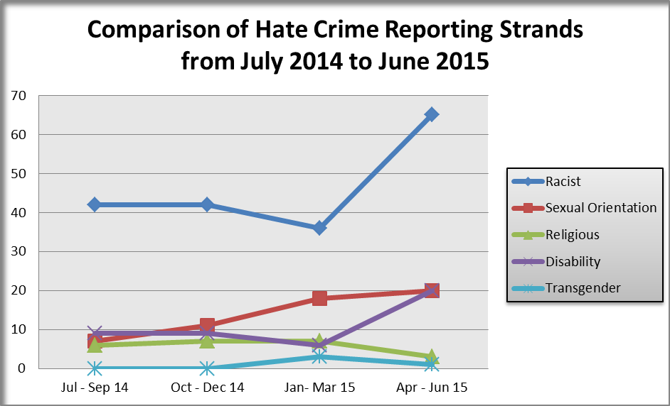Any criminal offence can be a **hate crime** if it was carried out because of hostility or prejudice based on disability, race, religion, transgender identity or sexual orientation. A **hate incident** occurs when a **victim or anyone else believes** an act of violence or hostility was motivated by hostility or prejudice based on the areas of diversity outlined above. Key findings highlighted in the Constabulary’s Hate Crime Problem Profile outlined that between November 14 and October 15 there were 447 hate crimes and incidents (+14%) compared to the previous 12 months. Racist hate crime/incidents are most frequently reported. The largest percentage increase in the last 12 months have however been seen in the Transphobic (91%) and Disability (52%) categories. 11% of public order offences have a hate motivation of which 69% were racially motivated. 1.5% of violent crimes offences have a hate motivation with racism as the strand with the most violent crimes, however this and religiously motivated crime has decreased in the last 12 months. With regard to location, the largest % increase of hate crimes/incidents has been in schools, however analysis shows that the peak day/time for incidents to occur are on Saturday’s between 9pm and 12 midnight and the average age of the victims of these cases is 34, however the numbers of youth victims and older victims have been increasing. Identified offenders of these cases average around 27 years and data suggests that offenders are getting younger. Whilst the problem profile has identified that the majority of hate victims have an ethnic appearance of “British” it also notes that the ethnicity and nationality of the victim is not necessarily a reflection of the ethnicity, nationality or religion that the hate was directed to[18]. AWAZ Cumbria reported that during the period March 2014 to April 2015 they had supported 10 service users aged between 20-65 years. AWAZ quoted that from victim feedback, the 3 main identifiable gaps in service provision/support in Cumbria over the last 12 months are;

* Inconsistency in quality of information and support from service providers across various localities within Cumbria.
* Lack of information sharing and appropriate signposting between and across different agencies.
* Some people from BME backgrounds and those who have difficulty communicating in English tell us they have difficulty navigating through the system.

In the last 12 month period the 3 main issues/concerns raised by AWAZ Cumbria service users are:

* Lack of empathy and support/lack of available information in a variety of languages/over-emphasis on the use of internet-based services.
* What would service users like to see improved or in place in Cumbria?
* To have the issues highlighted above addressed.

It is widely recognised that hate crime and incidents are under reported. In 2014 the Constabulary reviewed the Hate Incident reporting centres around Cumbria and introduced online reporting, as a result of which 25 incidents of hate crime were reported online to Cumbria Constabulary during a 12 month period. Initiatives such as the multiagency “Know Your Criminal Justice Day” events and Hate Crime Workshops have been held county wide. At one event there was disclosure of 3 Hate Incidents which hadn’t been reported and it is likely. The Constabulary also deliver classes in schools about identity, stereotyping and prejudice. All of these initiatives may have contributed to the increased reporting of hate crime and incidents highlighted above, which is a positive indication of improved public confidence in reporting.[19]

|  |
| --- |
| Recommendation 14: Programme for Perpetrators of Hate Crime |
| Recommendation: Design and deliver a Hate crime related performance to be delivered to juveniles to raise awareness of hate crime |

# Domestic Abuse

1 in 4 women experience domestic or sexual violence in their lifetime and between 6-10% women suffer domestic abuse or sexual violence each year. Whilst the majority of cases affect women we know that some men are victims of domestic abuse and sexual violence and it also affects the lesbian, gay bisexual and transgender communities. Domestic Abuse has more repeat victims than any other crime.

The cost to Cumbria of Domestic Abuse and Sexual Violence is £48million per year in direct costs and is estimated to be £151 million in respect of human and emotional costs (e.g. loss of productivity.

There is one call per minute to the Police in the UK and over 500 calls per month to the Police in Cumbria, less than 40% of Domestic Abuse and Sexual Violence cases are reported[20]

The number of domestic abuse incidents in Cumbria has fallen, domestic abuse incidents with a repeat victim have also fallen from 3,237 to 2,949: 288 less incidents. The number of incidents with a repeat perpetrator has fallen from 3,354 to 3,130: 224 less incidents. However incidents with a 1st time reporting victim has increased by 11% from 4,311 to 4,418: an increase of 107 incidents. This can indicate that victims of domestic abuse feel more confident to report this serious offence. For the 12 months to October 2015, the conviction rate for domestic abuse cases that went to court was 84%.[21]

The number of Domestic abuse crimes in Cumbria clearly remains an issue. Analysis of crime data for period of April 14 to March 15 indicated that there were 2217 offences recorded with a domestic abuse marker; in 38% of these offences the victim had a marker for alcohol. During this same period there were 7056 domestic abuse incidents recorded on Cumbria police PVP SLEUTH system. [22]

Cumbria Constabulary recently conducted a review of domestic abuse in Cumbria in order to evidence the current understanding of the problems associated with this type of crime. The scope of the review analysed 3 years data from 01/01/2012 to 31/12/2014 and highlighted the following;[23]

* The largest proportion of victims and offenders were between the ages 21-30 years.
* 5% of all domestic violence crimes in 2014 involved a child aged under 18 years as the victim.
* 4 out of the 9 murders during the 3 years analysis period were related to domestic abuse.
* 76% of domestic violence offences were violence against the person offences; this includes the category of harassment.
* Likewise 72% of all domestic violent crime in 2014 were assault and harassment offences, with harassment increasing most significantly (+148%). Harassment is now identified as being more frequently linked to domestic abuse.
* Over the 3 year period, West Cumbria consistently experienced the highest number of domestic violence crimes.
* At single NPT (Neighbourhood Policing Team) level, Barrow Borough had significantly more offences than any other NPT.
* North Cumbria experienced the largest percentage increase in domestic violence offences over the 3 year period with an increase of 54% when comparing with 2012.
* Over the 3 year period domestic violence crimes and incidents peaked during the summer, most notably during the month of August. There was also a notably significant increase during the Christmas and New Year festive period.
* Weekends are the peak days for domestic violence crimes and incidents during the 3 year period. Evenings to early hours of the morning were the peak times. Incidents were also high on Mondays; this may suggest a pattern of reporting domestic violence the next day.

**Linda**

“He broke my nose during one incident, he wouldn’t allow me to work or socialise, He was very controlling. I haven’t reported it before because I was trying to keep everything together; I thought it was important to keep the family together. But I can see now that it is affecting the children, they have reached an age where they understand what is happening and I can’t hide or protect them from it any longer”

**“I never criticised him to the children but can see his behaviour replicated by them now and again in their attitude and lashing out”**

* In 2014 the Football World Cup impacted on domestic violence levels with notable increases on the three dates that England played. .

When comparing area profiles with Cumbria Constabulary’s problem profile on domestic abuse, Barrow Borough has the highest number of domestic violence offences with Copeland featuring second and Allerdale third highest over the three year period from 1st January 2012 to 31 December 2014. Whilst there is a link between domestic abuse and areas of high levels of deprivation; it should be noted that domestic abuse is under reported and does occur between all social classes and within more affluent and rural areas of Cumbria.

## Let Go Data:

Let Go deal with high and medium risk domestic abuse victims, data collated by the specialist support service tells us that;

Between April 2014 and March 2015 399 victims sought their specialist support services.

* 96% were female and 4% male. Of these, 376 were white British or Irish, 13 were BME with the remainder made up of Asian, Arab and other nationalities.
* Jealous and controlling behaviour was encountered by 80% of the victims with 65% also being victim of Harassment and Stalking, 59% suffering physical abuse and 20% being subjected to sexual abuse.
* 21% of clients accessing their services had children under 3 years, nationally this figure increases to 61%.
* There is a clear link between volume of domestic abuse incidents and deprivation, 50% of clients accessing Let Go services have an annual income of less than £15,599.

(See Case Study-Annexe 3)[24]

## IDSVA Data:

Between July and December 2015 a total of 80 cases of domestic violence in South Cumbria were identified in the following departments within Morecambe Bay Hospital Trust.

|  |  |
| --- | --- |
| A& E | 55 |
| Acute | 2 |
| Paediatrics | 4 |
| Community midwifes | 2 |
| Diabetes nurse | 1 |
| Maternity | 7 |
| Ward | 1 |
| Labour ward | 1 |
| Children’s out patients | 2 |
| out patients | 3 |
| Intensive care | 1 |
| Women’s and children’s | 1 |

The victim’s age ranged between 16 years to 90 years with a higher percentage of reporting from the younger people and this steadily decreasing with age. There were 76 female victims and 4 male. The number of victims attending hospital as a result of DV who had physical injuries was 40, 26 suffered emotional abuse. 8 had mental health difficulties. There were 6 reports of Sexual Assaults within the hospital in the 6 month period.

There is no clear pattern at this time of peak times/days in respect of DV cases attending hospital and reporting the incidents

|  |  |  |  |  |  |  |  |
| --- | --- | --- | --- | --- | --- | --- | --- |
| Time of day | Mon | Tue | Wed | Thur | Fri | Sat | Sun |
| 00:01-03.00 |  | 1 | 1 |  | 1 | 1 |  |
| 03:00-06.00 | 1 | 1 |  |  |  |  | 3 |
| 06:01-09:00 |  |  |  |  |  |  | 3 |
| 09:01-12:00 | 4 | 2 | 4 | 6 | 2 |  | 1 |
| 12:01-15:00 | 4 | 1 | **1** |  | 2 | 2 |  |
| 15:01-18:00 | 3 | 3 | **2** | 3 | 3 | 2 | 1 |
| 18:01-21:00 | 1 | 1 | **5** |  | 1 |  | 1 |
| 21:01-00:00 | 2 | 1 | 1 | 1 | 3 |  | 2 |

Across North and West Cumbria, over a similar period, 51 cases of DV were identified. Of these, 49 victims were female and 2 male. One of the male victims was aged 88, White British, the perpetrator was his son. The second male victim aged 31 was Bangladeshi and the perpetrator was his female partner. One of the 51 perpetrators was 14 years old.

The age range of victims was as follow:

|  |  |  |
| --- | --- | --- |
| Victim Age | Number | Percentage of Total |
| 16-19 | 6 | 11.8% |
| 20-25 | 14 | 27.5% |
| 26-35 | 13 | 25.5% |
| 36-49 | 12 | 23.5% |
| 50-65 | 2 | 3.9% |
| 66+ | 4 | 7.8% |

27 (53%) of the 51 victims identified had children under the age of 18. Of these, 8 (30%) were also pregnant. Of the 49 female victims, 15 of those were pregnant (30.6%).

Victims in 42 of the cases reported physical abuse, 5 of those victims also disclosed emotional abuse. Of the 51 cases, there were 6 cases of emotional abuse, 1 of those victims also disclosed verbal abuse. There were three reports of sexual abuse.

As in South Cumbria, majority of cases were identified in A&E

|  |  |  |
| --- | --- | --- |
| Source | Number | Percentage |
| Midwifery | 11 | 22% |
| A & E | 26 | 51% |
| Other NHS Acute Trusts | 1 | 2% |
| Police | 1 | 2% |
| Let Go | 1 | 2% |
| Occupational Health | 3 | 6% |
| Wards | 8 | 15% |

## Freedom Data:

Data from the specialist support service provided by Freedom in West Cumbria tells us that from 1st April 2014 to 31st March 2015.[25]

* 556 clients were referred/supported by them.
* 61% of the referrals were from Allerdale with 52% of these coming from the most deprived areas of South Workington, Maryport and Wigton.
* 31% were from Copeland with 43% of these coming from the most deprived areas of South Whitehaven and Cleator Moor.
* 8% of referrals were from the outside of West Cumbria.

There were 443 children recorded as being involved in or in a household with domestic violence being an issue in West Cumbria.

* At 1st April 2014 there were 42 children and young children engaging in 1-1 counselling.
* A further 126 children and young people were referred from 1st April 2014 to 31st March 2015. Ages of the new referrals show:-
* 4 children were aged 0-4
* 45 children were aged 5-9
* 35 children were aged 10-15
* 21 young people were aged 16-18
* 21 young people were 19 years old

|  |
| --- |
| Recommendation 15: Programme addressing Domestic Abuse with an holistic approach |
| Recommendation 16: Programme addressing Domestic Abuse within Adolescent Relationships |
| Recommendation 17: Programme addressing Domestic Abuse – children on parents |
| Recommendation 18: More refuge/accommodation needs to be made available to victims of domestic abuse in West and South Cumbria. |
| Recommendation 19: Production of a DVD training tool relating to Domestic Abuse in Adolescent Relationships |

# Harassment and Stalking

The number of harassment offences in Cumbria has increased by 31% from 631 to 825 offences and makes up 25.7% of the total increase in violence against the person. As mentioned previously, the Constabulary has seen an additional 190 crimes recorded during April to November 2015 when compared to the same period last year because of the introduction of new offence codes by the Home Office. Of the 190 crimes, 173 crimes fall under new offence codes that are grouped as harassment. So far this equates to 24% of the total increase in crimes from April to November 2015.

In the Home Office Consultation paper in respect of Stalking(December 2015) The Right Honourable Teresa May MP describes stalking asan insidious and devastating crime which, at its most extreme, can lead to the loss of innocent lives. As part of their wider work to tackle violence against women and girls (VAWG) the government are addressing stalking. The work they are driving in this area has been captured in a refreshed VAWG strategy published recently.

The government have introduced new legislation to fill a gap in the law to tackle stalking and driven a programme of training for police and prosecutors to ensure that stalking is recognised and dealt with effectively. However, they want to be absolutely sure that they are doing all they can to protect victims of this frightening and often hidden act where behaviour can cause considerable fear and distress, irrespective of whether a prosecution can be commenced.

In her forward, Teresa May outlines that the nature of stalking can be delusional and obsessive with offenders going to extreme lengths to contact, follow and monitor their victims and is determined that this Government will do everything possible to identify the fixated nature of stalking behaviour at the earliest opportunity, protect victims and intervene to deter perpetrators before stalking behaviour becomes entrenched.

As stalking can take place in the context of an ongoing pattern of domestic violence and abuse the government have introduced a range of measures to protect victims in these circumstances, including the Domestic Violence Disclosure Scheme to alert people to previous violent offending, and the Domestic Violence Protection Order which allows for protections to be put in place for victims irrespective of whether a prosecution can be commenced. Alongside the new offence of coercive or controlling behaviour, and the new stalking offences themselves, these measures are helping to protect victims from this abuse.

However, in around half of cases, it seems stalking is taking place where only a very casual acquaintanceship exists between the perpetrator and their victim. While it is encouraging that prosecutions under the legislation the previous Government introduced in 2012 are increasing, there may still be a gap between the time when the offending behaviour begins and the time when a prosecution can be commenced where we could be doing more to deter the perpetrator from their obsession. The actions of a stalker can seem innocuous on the surface and there is a risk that the developing fixation, which may differentiate the stalker from the harasser, could be missed and therefore not addressed in the early stages when there is the best chance of heading off a prolonged campaign of stalking which may last for many years and cause significant harm to the victim. On that basis the government have recently consulted with victims and those who work in this field to understand how they can offer the best possible protection against stalking and ’stranger stalking’ in particular.

Between 1st April 2014 and 31st December 2015 there have been 23 recorded cases of Stalking in Cumbria. Of these, 3 cases involved “Stranger Stalking”.[26]

|  |
| --- |
| Recommendation 20: Consider implementing practices in line with the refreshed VAWG strategy. |

# Sexual Violence

When comparing police data from April 14 to March 15 with the previous year, sexual offences in Cumbria increased by 68%, from 415 to 696. During this period rapes increased by 62% from 124 to 201 and other sexual offences increased by 70% from 291 to 495 this increase in line with the national trend.

Victim Support reported that during April 2014 to March 2015 they received 482 referrals for victims of sexual abuse, during this period 48% of their client base were females compared to 44% male for all crimes and the highest representative age group were 25 to 34.[27]

**Sarah**

“The male doctor on duty looked at me as though I was a piece of meat and offered no help.”

“About 5 weeks after the rape my mam told the police officer that she was worried about me, I was really struggling. The Police said I couldn’t have counselling until after the trial but they got me an ISVA. I got on really well with the ISVA; she has been great, very supportive”.

**“The service at the SARC was excellent.”**

Between November 1 2013 and October 31st 2014 Safety Net Advice and Support Centre received 184 referrals, this was a 21% rise on the previous year. Of those referrals 148 were to help females and 36 males. Eighty one were to help children under the age of 16. More than 100 individuals referred were from North Cumbria, 67 from the west and 11 from South Cumbria. In the following 5 months Safety Net received a further 89 referrals.[28] The Birchall Trust provides support and counselling for the majority of victims of sexual violence in the south of the county.

The introduction of the Bridgeway Sexual Assault Support Services will hopefully ensure that any gaps previously identified for victims of rape and sexual assault will be addressed (See Case Study-Annexe 4). That said, the figures recently published by HMIC with regard to the number of Rape cases actually proceeding to court and then receiving a guilty verdict is understandably difficult for victims to comprehend.

|  |
| --- |
| Recommendation 21: Consider Introduction of a multi-agency Rape/SV scrutiny panel and SV MARAC |
| Recommendation 22: Introduction of a Juror 13 type project |
| Recommendation 23: Adopt the recommendations of the reports Getting it right in Cumbria for Adults following Rape and Sexual Assault and Getting it right in Cumbria for Children and Young People following Rape and Sexual Assault |

## So called Honour Based Violence, Forced Marriage and Female Genital Mutilation

Intelligence tells us that there have been a very small number of cases where victims have fled to Cumbria to avoid a forced marriage however as with most serious victim-based crimes there is an element of under-reporting. We cannot however confirm whether or not females living in Cumbria have been forced into marriage against their wishes or whether they have been taken from Cumbria to be married elsewhere. There is no recorded evidence of any victims of female genital mutilation. That said, we cannot assume that because we have no evidence, that this is not happening in Cumbria and we need to have some understanding and be prepared for if the circumstances arise.

Nationally 141 British girls have been murdered by their own family in so-called ‘honour’ violence since 2003. The biggest complaint from victims is the lack of support and knowledge from professionals.

In accordance with a recent report from the HMIC, Cumbria is one of the 40 forces that were prepared to some extent to protect and support victims of HBV effectively. Avon and Somerset Constabulary have been singled out by HMIC as excellent in this field.

|  |
| --- |
| **Recommendation 24: Consider the use of Educational resources and awareness raising used by Avon and Somerset Constabulary and the recommendations of the HMIC report.** |

## Trafficking, Child Sexual Abuse and Sexual Exploitation

Refugees and asylum seekers are at higher risk of CSE for various reasons, such as they have little or no possessions, limited support, language barrier, and other vulnerabilities.

60% of trafficked people into the UK go missing within 3 months of being placed in local care. Usually never located again, and usually re-trafficked.

Recognising the existence of child sexual exploitation is a key difficulty in tackling child sexual exploitation as many victims do not recognise or acknowledge that they are being exploited.

Under-reporting of online grooming is problematic as some victims may perceive offenders as friends or romantic partners, rather than as abusers or offenders.

* Offenders are known to create fake online personas to portray themselves as a similarly aged peer, often of the opposite gender.
* 22% of industry reports submitted to CEOP in 2011/12 related to self-generated indecent imagery, involving practices such as ‘sexting’ – the self-generation and exchange of indecent user imagery indicates a shift in the nature of online risks. [in 2012, CEOP recognised this as one of the biggest risks posed to young people]

Within Cumbria understanding and knowledge of CSE is developing with the help of the Cumbria Safeguarding Hub, created in November 2012. Cumbria police and partners are working together to understand the threat and allocate resources accordingly.

The evidence base used to understand the current level of CSE in Cumbria was a comprehensive research project undertaken by Cumbria Constabulary, which indicates that the majority of CSE offences fall into the sub-categories of ‘inappropriate relationships’ and non-familial child sexual exploitation by lone offenders’. The report, previously mentioned, which was commissioned by the Police and Crime Commissioner in relation to children missing from home in Cumbria, conducted by Barnardo’s suggests that there has been some evidence of a gang culture involving the exploitation of young people.

**OPCC**

**“The protection from Child Sexual Exploitation is everyone’s responsibility”**

A total of 164 crimes were identified as ‘potentially’ linked to CSE meaning that CSE equates to 42% of the total for those offence types (sexual offences with a victim under 18, indecent images of children and child abduction).

* 63% of victims of sexual offences recorded during 2014 were under 18.
* 42% of sexual offences recorded in 2014 with a victim under 18 were historic
* Most CSE offences during 2014 occurred in West Cumbria in all categories of CSE.
* 91% of contact child sexual abuse victims are females and in 89% of cases the victim is between the age ranges of 12 to 15.
* 93% of online sexual abuse victims are females with the majority of victims falling between the age ranges of 13 to 14.
* Only 14% of victims were identified as being in care; however it should be noted that these individuals are considered being at higher risk of exploitation.
* Under 16 teenage pregnancy rates in Carlisle and Barrow are above the national average, however when considering Cumbria as a whole the under 16 teenage pregnancy rates fall below the national average.
* School absenteeism is a key risk factor in violence, risk of CSE, injury, substance abuse and psychiatric disorder. Cumbria has a total of 8.9% of persistent absences in secondary schools, ranging from 6.3% in South Lakeland to 10.9% in Eden: higher than the national average in 2010/11 of 6.1%.

In 2013/14 there were 9,644 Vulnerable Child reports of which 139 were relating to Child Sexual Exploitation. In addition Vulnerable Child reports increased by +63% in 2013 compared to 2012. [29]

At the Turning the Spotlight conference on the 8th October 2015, the overall consensus from all the speakers was that male victims of CSE are treated as a minority in the bigger picture. This is in relation to identification of victims, support, education, resources, and media campaigns.

Some of the key findings in the research carried out by Barnardo’s into exploitation of boys in 2013 , published in 2014 were;

* 2008-2013 Barnardo’s supported 9042, 8-17 year olds affected by CSE.
* A third of these service users were male.
* Boys level of risk was significantly higher at referral (usually via CJU).
* Girls would self-harm in private, whereas boys would self-harm in public by causing fights, public disorder and generally down turn in behaviour.
* Understanding of criminality as a possible response to trauma.
* Offending girls considered/treated as CSE victims, boys are not usually considered.
* Referred males had a much higher disability rate 35% vs 13%.
* Referred males had a higher youth offending rate 48% vs 28%.

It was recognised that some boys who are groomed would rather be prosecuted (crime or drugs) than be seen as a CSE victim. Some barriers to disclosure included

* Victimisation / reputation / embarrassment / being judged.
* Avoidance of “victim” identity.
* Victims led to believe they will be labelled as gay.
* Victims led to believe that the police are homophobic.
* Victims will question their masculinity.
* Lack of knowledge amongst professionals of signs and indicators of CSE.
* Cultural challenges.
* Lack of specialist support around mental ill health and trauma.
* Lack of male only support.
* Environment, i.e. feeling uncomfortable in counselling room due to décor, layout, location, professionals present, etc.

It was suggested that the police would notice girls with older males or in a taxi late at night with suspicion, but would not notice a young male in the same position. However, society sees boys as being able to look after themselves, and therefore signs not recognised by professional, parents, carers and members of the public. Society, including professionals need to consider boys/males without being gender specific. See them as being a child, or consider the circumstances as if they were female. Nationally there is a limited awareness in schools, teachers, governors and parents around boys being victims and recognising the signs.

Improvements are being made locally to the reporting of CSE and action plans are in place with Cumbria police and partners across the county working together in order to understand the threat of child sexual exploitation and to allocate resources accordingly.[30]

Members of the Local Safeguarding Children’s Board (LSCB), which include Schools, Children’s Services, the NHS, Barnardo’s, the Youth Offending Service and Cumbria Police, discussed CSE at their December 2015 meeting The group watched a film about CSE which they suggested should be delivered in schools (year 9) and youth settings.

The group think that more information should be available for parents / carers and also for young people. They felt that the LSCB could promote family time – schools could promote family life, values and relationships in assemblies / PSHE.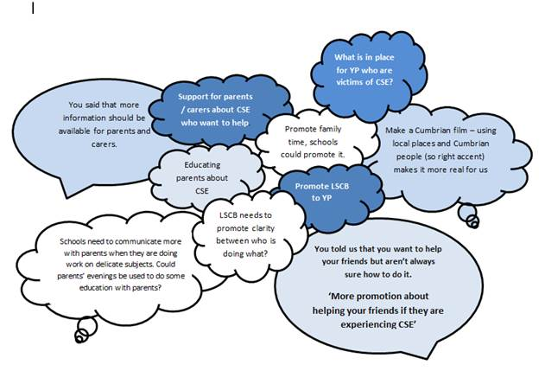

*Source: Cumbria LSCB – Young People’s Advisory Forum – December 2015*

At a meeting of the CSE and Missing from Home (MFH) Working Group the following issues have been identified:

* Need to ensure clear pathways are in place for referral to and from services, e.g. mental health services, A&E and timing clear.
* Lack of specialist service just targeting boys/ males (e.g. Blast in other areas).
* Mentoring/ buddy support services e.g. young adults support who have had a similar experience?
* Out of hours support for children and families.
* Access to CAMHS in case of sexual abuse (including CSE).
* Drug and alcohol services.
* Transition to adulthood/ to adult services- support at this stage.
* Appropriate housing for victims including CSE.
* CSE-trained/ training for foster carers?
* Jargon-free training for professionals including on engaging and talking to young people.
* Multi-agency CSE team.
* Sexual health drop-in service in schools- with LGBT links; C-Card scheme.
* Named CSE champions for all agencies (and SV champions).

**Barriers**

* Lack of resources.
* Gaps in knowledge of what CSE is.
* Unclear/ lack of accountability- by whom and when?
* Unclear referral routes.
* Clear understanding and data on CSE categories and whether these cover the right cases.

The group are already looking to follow up on a number of these issues, such as mental health support, mentoring, and support for male victims and dependency programs for children.

Between February and March this year 38 performances of “Chelsea’s Choice”, a drama production around CSE was performed in secondary schools across the county to almost 4,000 school children (years 9 and 10), staff and parents .

|  |
| --- |
| Recommendation 25: Further consideration should be given to the fact that being in care  may make it more difficult to identify incidents of CSE and is dependent on staff being aware  and vigilant for signs of CSE. |
| Recommendation 26: Further role out of the performance Chelsea’s Choice, to children across  Cumbria |
| Recommendation 27: Increase understanding of child sexual exploitation, in the profession and wider community, for example raising awareness through schools, faith networks and other community based groups. |
| Recommendation 28: Gather information to map the needs and identify levels of child sexual exploitation, locations and circumstances where children are particularly at risk. (This exercise should be periodically or ongoing?) |
| Recommendation 29: Adopt the recommendations outlined in the Constabulary’s CSE Problem Profile. |
| Recommendation 30: Health services need to think about what they can do for children in a more holistic way, and not just refer them to a mental health service. |
| Recommendation 31: There is a need for more specialist third-sector projects where counsellor’s follow-up missed appointments. Longer term support is needed compared with what is available. |
| Recommendation 32: Consideration needs to be given to CSE Awareness/Safeguarding being a condition of taxi drivers being licensed to operate. |

# Cyber Crime

The term Cyber-crime refers to two distinct, but closely related criminal activities:

* **Cyber-dependent crimes** are offences that can only be committed by using a computer, computer networks or other forms of ICT. These acts include the spread of viruses and other malicious software, hacking and distributed denial of service.
* **Cyber-enabled crimes** are crimes that are increased in their scale or reach by the use of computers, computer networks or other ICT. Unlike cyber-dependent crimes, they can still be committed without the use of ICT, such as:
  + Fraud (including mass-marketing frauds, phishing e-mails and other scams; online banking and e-commerce frauds.
  + Theft (including theft of personal information and identification-related data).
  + Sexual offending against children (including grooming and the possession, creation and/or distribution of sexual imagery).

Cyber-crime is closely linked to child sexual exploitation and problematic in identifying and prosecuting perpetrators due to complexity and enormity of the world-wide web, which allows perpetrators identities and whereabouts to remain hidden, perpetrators will often change and take on different pseudonyms to avoid detection. This allows them to target an individual directly through emails or viruses or by hacking into their online accounts, home and/or work computers, mobile phones and other electronic devices.

When analysing crime data from April 2014 to March 2015 less than 1% had cyber–crime markers attached, out of the 31 crimes identified as being linked to cyber-crime; 58% related to harassment and blackmail offences, 35.4% related to sexual offences, the majority concerning ‘Causing or inciting a child to engage in sexual activity’, the remainder of crimes, 6.4% were linked to theft offences.[31] Further analysis shows that of the 173 crimes recorded since April 2015, 60% (104 crimes) involved a cyber element or mobile phone use. The remaining 40% appear to mostly involve telephone calls to mobiles/home phone numbers and letters.[32]

|  |
| --- |
| Recommendation 33: Improving the measurement and recording is critical to understanding whether the scale of cyber-crime is increasing or decreasing and how aspects of the crime are evolving over time. This may include forces using the Home Office ‘Cyber Flag’ more robustly when recording crimes linked to the internet. |

# Acquisitive Crime

Acquisitive crimes are those in which the offender acquires or takes items from another person, and therefore covers a number of different offence types, including Theft from motor vehicle, theft of a motor vehicle and burglary:[33]

* Theft from motor vehicle have reduced by -15.8% compared to the previous year and a reduction of -35.2% over a three year period.
* Theft of motor vehicle has decreased slightly in 2014/15 compared to the previous year, a reduction of -3.9% or -12 incidents.
* Burglary (dwelling) has increased by +2.3% or 16 incidents in 2014/15 when compared to the previous year, with a +12.2% increase over three years.
* Burglary (other) crimes have dropped across the county by -23.4% or -375 in 2014/15 when compared to the previous year.

# Business Crime

In Cumbria, from April 2012 to March 2015 there were 18,778 crimes with an identified business marker; we estimate this figure to be higher if rural crime and tourism crime were added to the figure. The majority of the offences 66.2% or 12,444 related to all theft offences, including theft from shops and stalls, theft by an employee and other thefts not classified. Criminal Damage offences relating to business crimes equated to 23.7%, Burglary 9.1% and Violence against the person concerning harassment equates to 0.8%.

Over the 3 year period analysed April 2011 to March 2015 Carlisle had the largest volume of recorded business crimes equating to 21.4%, Barrow 15.2%, Allerdale 14.8% and Copeland 10.8%.

When including all ‘Theft from shops and stall offences’ for the period a further 1141 crimes are identified as being associated with a business crime (although it is worth noting that not all stall holders will be recognised as a business)[34]. According to the Crime and Community Safety Strategic Assessment for Cumbria 2014, levels of business crime remain relatively stable in Cumbria overall during 2014/15. Copeland has seen the largest downward trend in business (-20.7%), whilst South Lakeland has seen the largest increase (+18.6%). Shoplifting makes up nearly half of all business crime accounting for 47.6% of incidents. Criminal damage accounts for 21.9% of the total with all other theft offences making up 16.7%. [35]

# Rural Crime

The cost of rural crime in Cumbria in 2014 was £580,000[36]

The highest crime types linked to rurality is Criminal damage and Arson, All other thefts, and Non-domestic burglaries. However despite Criminal damage and arson being the highest crime type, there is still a statistically significant difference between rural areas experiencing criminal damage/arson at 30%, compared to urban areas that experienced 70% of the overall figure, indicating that you are more likely to experience this type of crime in an urban area.[37] 65.3% of the rise in cases of Criminal damage over the last 12 months (132 of the 202 additional offences) has been classified as ‘other damage’ which has mostly occurred in gardens and outside spaces such as damage to fencing, plant pots and post boxes. The biggest increase is damage to fencing rising from 116 to 160: +44 offences. The rise in criminal damage accounts for 11.2% of the total increase in crime.[38]

The National Rural Crime Network carried out a survey in 2015 which indicates that rural crime is under-reported. It is estimated that the cost of rural crime to the rural economy in England and Wales is £800m, equivalent to £200 for every household in the countryside. Respondents indicated that their fear of crime is increasing, with 39% of rural residents reporting they were very, or fairly worried about becoming a victim of crime, compared to 19% nationally.[39]

# Non-domestic burglary

Non-domestic burglary is the only crime which is shown as being marginally **higher** in rural areas at 628 (or 51%) in rural areas compared to 593 (or49%) in urban areas.

For the period of April 2014 to March 2015, Quad thefts remain the highest agricultural linked crime in Cumbria, with livestock thefts and Farm implements [relating to tools, generators, feeders and other machinery] also remaining popular items targeted by thieves. However these item types could be higher with further in-depth analysis of crime records which were not available at the time of analysis. [40]

|  |
| --- |
| RECOMMENDATION 34: That the recommendations from the National Rural Crime Network Survey are adopted; |
| Recommendation 35:  Cumbria Constabulary to Link in with Newton Rigg/ Cumbria University around new innovative ideas in tackling rural crime with NFU and other partners |

# Anti-Social Behaviour

The effects of Anti-social behaviour (ASB) on victims can be devastating. ASB falls into three main categories:

**Personal vulnerability** – results from an individual or group’s characteristics, identity or status e.g. mental or physical health status.

1. **Situational vulnerability** – For example, neighbourhoods that are socially or economically stressed may be more harmed by the occurrence of ASB. Similarly, areas with low levels of social capital or high crimes rates may be negatively impacted by events that, if they occurred in different circumstances would be less influential.
2. **Incidental vulnerability** –Most notably, this includes repeated occurrences, but also incidents perceived by the victims to be personally targeted.

In Cumbria there has been a -15% decrease in anti-social behaviour incidents in 2014/15 from 23,856 to 20,208. Youth anti-social behaviour has decreased by -27% in the same period from 3,872 to 2,821 and equates to just 14% of the overall total of anti-social behaviour incidents. That said, the number of crimes recorded has gone up, could this be related and be more about how incidents are recorded?

**Steven**

**“At one time a brick smashed through the living room window and landed on the sofa, if it had happened a few seconds earlier it would have hit my little granddaughter, she had been sitting on the sofa and just gone to the kitchen for a drink”**

Barrow continues to have the highest rate of ASB and youth ASB of all the districts in the county. A recent Cumulative Impact Policy was submitted to Barrow Borough Council, the report highlighted and evidenced that 69.9% of alcohol related anti-social behaviour were licensed premises, supermarkets and fast food outlets. Incident peak between 20:00hrs and 00:00hrs on Friday to Saturday, and 21:00hrs to 02:00hrs between Saturday and Sunday; the top 10 streets for ASB were all within the night-time economy locations.

Further analysis conducted on a dip sample of 28,900 anti-social behaviour incidents over a 3 year period from April 2011 to March 2015, where a victim has been recorded also evidences the findings in the cumulative impact policy for Barrow over all Territorial Policing areas which show an increase in alcohol-related anti-social behaviour over a weekend period. There is also a correlation in repeat victimisation reports and weekend/night-time economy.

The increase in alcohol related crimes has been witnessed in other parts of the county, including Copeland, with Whitehaven Town Centre accounting for 46% of all violent crimes, the town centre has a large number of licensed premises, within a defined stress area there are currently 27 pubs and night clubs, 6 restaurant style premises and 20 late night refreshment premises. When comparing crime within the SCIP area, 30% of all crime in Whitehaven was violent related, 46% of all crime and violent crime occurred within the proposed SCIP area. 47% of all anti-social behaviour incidents took place within the proposed SCIP area. Peak time for both violent crime and anti-social behaviour occurred within the hours associated with night-time economy and 76% of alcohol related anti-social behaviour incidents took place in the proposed SCIP area. A Cumulative Impact Policy has been submitted to Copeland Borough Council currently the proposal for adoption of a CIP area is pending due to forthcoming electoral changes.

## Anti-social Behaviour Strands:

*63% of the incidents relate to nuisance, 34% relate to personal and 3% concerning reports of environmental issues.*

When comparing the volume of incidences of ASB per NPT, Barrow, Copeland, Allerdale and Carlisle East appear to experience the majority of incidents. Whilst ASB occurs predominantly in urban area’s it does also occur in rural areas too. A recent National Rural Crime Survey suggested that rural crime is under-reported, yet the fear of crime is relatively high and increasing with the emotional cost of crime.

## Alcohol Level as a contributing factor:

When comparing the age range against and gender of perpetrators; there are significantly more males than females identified as committing anti-social behaviour incidents. From data it appears that males start offending at 7 years continuing to 17 years before decreasing; whereas females appear to start at 9 years continuing to 16 years then decreasing after 16 years of age. Males equated for 79% of all anti-social behaviour incidents that were referred to its Your Choice’ whereas females accounted for 21%.

## Analysis of Qualitative Questionnaire – ASB

The OPCC carried out a qualitative survey on anti-social behaviour which sought the views and experience of police officer dealing with anti-social behaviour incidences. [41]

* Hotspots were identified as being predominately urban, although rural areas also experience a certain amount of anti-social behaviour.
* Causation factors surrounding anti-social behaviour were believed to be youth gathering, peer pressure and boredom, lack of activities to dissuade from anti-social behaviour.
* The most prolific of offenders of ASB were 13-17yrs equating to 20%, followed by 26-35yrs, 17% and 18-25yrs at 15% (This would evidence that the majority of ASB is linked to youth anti-social behaviour and night-time economy issues)
* Additionally, the majority of victims were within the 56-65yrs equating to 18%, followed by 0.12yrs at 16% and 13-17yrs accounting for 15% of the overall total.
* Themes or trend surrounding anti-social behaviour appears to be youth ASB, neighbour problems such as boundary disputes and general animosity between families. There also appears to be suggestions that offenders will target vulnerable people.
* Further recommendation or comments concerned the lack of effective non-police during known peak times for ASB. More integrated partnership working to address this issue, alongside dispersals and engagement and more effective community remedy options.
* There was an even diversion regarding whether the majority of perpetrators were ‘Adolescent Limited Offenders’ or ‘Life Course Persistent Offenders’ there is general consensus that perpetrators fit both categories and will either desist from offending in late adolescence or their offending behaviour will escalate to more serious crimes.

|  |
| --- |
| Recommendation 36: Consider the introduction of Mediation Services |
| Recommendation 37: Introduction of Anti-social Behaviour Caseworkers |
| Recommendation 38: Local Councils seriously consider the adoption of Cumulative Impact Policy’s submitted by the respective borough commanders across the county. |
| Recommendation 39: Support for victims of Anti-social Behaviour should be accessible regardless of whether or not the victim chooses to report the behaviour to the police or another statutory agency. |
| Recommendation 40: Target Hardening measures should be part of the package available for all victims of crime and antisocial behaviour irrelevant of where they live in Cumbria. |

# Road Safety: Killed and Seriously Injured (KSI) Statistics

During 2014 the percentage of all people killed and seriously injured (KSI) in road traffic collisions in Cumbria decreased by -5.4% from the previous year. In terms of numbers this represents a reduction of -13 KSIs. Child KSIs make up 5.3% of the total. Fatalities account for 11.1% of the total.

However, when taking KSIs and slight injuries into account, the total number of casualties actually increased by +10.4% (+175) in 2014 compared to 2013, ending a 10 year trend of decreases year on year since 2003. Road safety is managed in a multi-agency partnership across the county via the CRASH group, which closely monitors data to make improvements to roads and to tackle unsafe driving. In December 2015 the CRASH partnership launched its annual drink and drug drive campaign and the Constabulary produced an awareness video to show the affects this behaviour can have on communities. The Cumbria Road Safety Partnership aim to review road safety in Cumbria over the coming year, and take appropriate action as required.[42]

|  |  |  |  |  |  |
| --- | --- | --- | --- | --- | --- |
| DfT 2014 | 2012 | 2013 | 2014 | Numerical Change 2013-14 | % Change 2013-14 |
| All KSIs | 196 | 239 | 226 | -13 | -5.4% |
| Child KSIs | 10 | 15 | 12 | -3 | -20.0% |
| All fatal | 30 | 27 | 25 | -2 | -7.4% |
| Slights (Non KSI Casualties) | 1,511 | 1,437 | 1625 | 188 | 13.1% |
| Total Casualties | 1,707 | 1,676 | 1851 | 175 | 10.4% |

The Department of Transport recognise that it is difficult to isolate the impact of a single factor in casualty trends, but long-term decreases are likely to be driven by a combination of factors including: road safety education and training; improved vehicle and highway technology and engineering; grater compliance with speed limits; improved medical care following collisions such as the creation of major trauma centres. [43]

# 

# The Case for Change –

Every Crime or case of Antisocial Behaviour has at least one victim, more often than not it is a whole family that is affected in one way or another.

The reviews carried out on behalf of the Commissioner in 2014 clearly identified that the journey for victims through the Criminal Justice process is difficult and many victims said that they “wouldn’t do it again” and wouldn’t wish anyone they knew to go through it. A clear message coming through from both victims and those who support them was the level of impact which crime and antisocial behaviour

can have on someone’s life. Whilst a flexible and tailored approach is important for delivering effective services to meet individual need, in many cases this results in a cluttered and confusing landscape for both victims and professionals working in the field. Some services run concurrently through the Criminal Justice System whilst others run sequentially. The Victim Services landscape in Cumbria is extensive and complex; it is not unusual for some victims to have contact with a minimum of 10 different organisations and numerous individuals throughout their journey of Criminal Justice. Are we really keeping victims at the heart of all we do in the criminal justice process? Supporting Victims is not just a tick box exercise. Whilst everyone has and is entitled to their opinion, in their training, Victim Support volunteers are advised that they “leave their opinion at the door”. Victims should be listened to, taken seriously and treated with respect throughout the Criminal Justice process. Support can take many different forms, a quick phone call simply offering support can be very much appreciated by some Victims, whilst others who may have more have been more severely affected by the crime may require a more specialist and lengthy support package. Every case is unique. When working in this environment on a daily basis it is easy to become complacent, lack empathy and use terminology and language which victims don’t fully understand. Cases should proceed on evidence and not on whether the victim will make a good witness.

Claire

“From the moment it happened until he was sentenced was a long time and I felt in Limbo and not been kept in the loop”.

**“I got a black eye, scratched nose, bruised ribs, had an epileptic seizure and was hospitalised, but because she told the Police that she was sorry, she didn’t even know me and hadn’t been in trouble before, she got a caution”**

**Claire**

“Because of this ordeal I’ve missed 12 months of my apprenticeship but my employers have been great, they have kept my job open and I am going back soon to do my final year”

At present many aspects of the criminal justice service are not as responsive to victims’ needs as they could be.

The first contact for victims who choose to report their crime is often with a Police Officer and that person sets the tone for the victim’s confidence in the criminal justice system. The College of Policing have produced a Code of Ethics for all Police Officers and this is widely publicised in all Police establishments throughout Cumbria. It is extremely important for victims to be kept up to date about what is happening around **their** case and there is clear guidance about when and who is responsible for this in the Code of Practice for Victims.

**Victims Advocate -** Whilst Cumbria is still a safe and beautiful place to live we need to acknowledge that we have clearly got some issues that are bigger than those nationally. We shouldn’t be complacent. The issues highlighted in this report are everyone’s responsibility and not just those of the PCC or the Constabulary.

**Natalie**

**“Just felt I needed to off load the whole experience”**

**“This has put a lot of strain on the family, some separate support for me and my husband would have** **been appreciated”**

|  |
| --- |
| Recommendation 41: All agencies need to use understandable language, give clear direction and better manage victim expectation |

**POLICE**-Whilst it is the responsibility of officers to gather evidence and put files together before passing them over to CPS, there seems to be more focus on “getting the file past CPS”  than ensuring that victims are kept fully up to date and getting the service they should.

It appears that the first port of call for our communities is to call the Police in a time of need and whilst to some extent this is flattering for the Constabulary, it needs to stop.  Emergency calls about individuals being “attacked” by birds in the garden or about the broken glass in the bus shelter down the road are inappropriate.  Spending hours on suicide watch when someone is in custody or hours caring and making arrangements for individuals with dementia or mental health issues is not the best use of Police time and certainly not in the best interests of the individual concerned.

In times when Police Officer numbers are reducing, they need to be available to deal with the prevention and detection of crime and ensuring that they are providing a good service to the victims of those crimes.

|  |
| --- |
| Recommendation 42: Better Partnership working, with Local Authorities, Health and other relevant organisations taking some responsibility and being active in addressing issues throughout Cumbria. |
| Recommendation 43: Multi Agency Hub approach to dealing with victims, avoiding them slipping through the net and ensuring that they receive the appropriate support. |

The choice of disposal options available to officers in respect of cases that they are dealing with also seems to be a bone of contention and causes confusion, doubt and discord amongst officers and victims alike. Whilst the Community Remedy method of disposal which was recently introduced by the government as a way of “giving victims a voice” in how their case should be dealt with, this is not in fact wholly true.  If an officer dealing with the case feels that the disposal option selected by the victim is inappropriate or unrealistic the officer decides on the Remedy Option, this is obviously then NOT the victims voice.

Frequent changes to policy and procedures do not help officers to deal with matters in a consistent way across the county.

|  |
| --- |
| Recommendation 44: ABE interviewing should take place in line with protocol and training should be rolled out to all Police Officers. |

**Sophie**

**“It happened in July last year(2014), he pleaded guilty in April this year(2015) but I still haven’t got my property back, the police have had my phone for 11 months I’ve had to get another mobile, I was scared to go out and couldn’t manage without one.”**

**“I’ve rang the police 20 or 30 times and made numerous statements but I’ve stopped reporting because the Police can’t or wouldn’t do anything so I thought what’s the point.**

**“The Police were brilliant”**

The length of time that victims have to wait for their property to be returned to them, in some cases 12 months for a laptop and 3 months for a mobile phone, is too long. When a victim has to go to the expense of funding another laptop or phone in the interim for the purposes of carrying on their normal daily affairs this is costly and could be interpreted as re-victimisation.

|  |
| --- |
| Recommendation 45: Speedier return of property seized for evidence. |
| Recommendation: Reminders to return property should be incorporated in Red Sigma Victim Case Management section |

Police Case Management Systems need to be updated with better Flagging and Tagging facilities/Markersso that they are better geared to ensuring multiple vulnerabilities can be marked up and cases/people can be linked to avoid victims having to repeat their story and having the responsibility of telling attending officers that the incident is connected to similar incidents (e.g. DA/Harassment etc.).

|  |
| --- |
| Recommendation 46: More robust needs assessments and flagging and tagging/marker systems to identify what support and protection is required throughout the criminal justice system especially in relation to vulnerable, intimidated, targeted and repeat victims, those with drug/alcohol and mental health issues and those with learning difficulties. |

**INTERMEDIARIES-** Some victims are entitled to an intermediary, **ALL** child victims under the age of 18yrs are entitled to a Registered Intermediary. Appropriate Adults are not Registered Intermediaries and whilst every child under 18yrs does not require the services of an Intermediary, Intermediaries should be appointed appropriately and in line with the Victims Code. There are issues about the availability of intermediaries and the length of time officers have had to wait to get an Intermediary to attend, sometimes 6-8 weeks. Until recently there were only 100 Intermediaries to cover the country. Referrals to the Intermediary service have risen from 511 in 2009 to 3,332 in 2014. A further 100 Intermediaries have recently undergone training however delay remains an issue. During some recent Intermediary training for PPU/CID Officers it was identified that in light of the fact that frontline officers are now going to be submitting their own simple crime files, they too should have some understanding and awareness of the role of the Intermediary.

|  |
| --- |
| Recommendation 47: More consideration given to the use of Registered Intermediaries. |
|  |
| Recommendation: Training/awareness raising with regard to the role of an Intermediary should be provided in initial police officer training. |

**WCU (Witness Care Unit) -** The Witness Care Unit is responsible for keeping the victim up to date about the case when it is in the court process however they rely on receiving full and timely information from the Crown Prosecution Service (CPS) before they in turn can link in with the Witness Service before the trial and in order to update the victim throughout. Staffing in the WCU are provided by the Police and CPS and has recently been restructured with Police staff dealing with all cases from North, West and South Lakes and CPS staff dealing with cases from Barrow and Lancashire.

**Katie**

**” The person who initially contacted me from the WCU was very good at explaining things and keeping me updated but when someone else took over the case she was nowhere near as helpful or caring”**

The whole point of Pre Trial Visits (PTV’s) is to try and put victims and witnesses at ease before they have to attend court on the date of trial with a view to achieving best evidence...

**Claire**

“Things should be more joined up and available to victims without having to chase around for information”

|  |
| --- |
| Recommendation 48: Funding should be available for victims and witnesses to attend Pre Trial Visits. |

**CPS (Crown Prosecution Service)-.** The number of positive outcomes from cases dealt with by CPS has increased. That said, it would appear, in the view of some victims, that it is becoming increasingly difficult for CPS to take a case forward and there has definitely been a reduction in the number of cases proceeding through the court process.  The fact that a significant number of cases are now dealt with by way of the ‘Out of Court Disposal’ method will of course attribute to this. The perception amongst a number of victims, witnesses and others who have spoken to the Victims’ Advocate is that, for CPS, taking a case to court is a business; this is certainly not the case for a victim.  As with other agencies, it is the view of the victim’s advocate, based on interviews with victims, that CPS need to show more compassion and tailor their service to the needs of individual victims whatever their ability or disability. Whilst CPS would say that decisions are always based on evidence and on the Code for Crown Prosecutors, that is not the opinion of some victims, particularly vulnerable victims who feel that cases only proceed if it is thought that they will “make a good witness”. An issue raised at the Victims and Witnesses Group was that Barristers only review cases a short time before the Trial.

**Naomi**

**“The guy from CPS had a quick word but said he would have to rush off because he was doing another sex case”.**

Some victims of sexual violence reported that there have been some issues around support at court. Whilst expectation of the victim needs to be carefully managed, agencies must not be precious and remember that the victim should be at the heart of their service. Whilst these types of cases have a high priority for the CPS, a Unit with specialist prosecutors and paralegal staff has recently been formed. Some victims report that the approach to support can sometimes feel more about ticking a box than meeting their needs. Improving the successful outcomes in cases is always a priority for the CPS and in the last available data – the CPS VAWG report for 2014-15 - Cumbria’s conviction rate for rape offences was 80%, which was the highest in the country.  National average was 60%. That said, the amount of not guilty verdicts are still of some concern.

|  |
| --- |
| Recommendation 49: Consistent use of ISVA support at court for victims of Rape and serious sexual violence in line with CPS protocol |
| Recommendation 50: Introduction of a project to establish the possible reasoning behind low level guilty verdicts in sexual abuse cases by juries in Cumbria |

**COURTS-**Plans are afoot to close 2 of only 4 courts available in the vast geographical area of Cumbria.  This will definitely not be in the best interests of victims in our area.   If the closures go ahead it would mean an overnight stay before the day of the court hearing for some victims who live in more remote areas of the county and who rely on public transport.  This would also impact on victims being able to access Pre Trial Visits to court to assist in putting them at ease to achieve best evidence (See Appendix 5).

The Trial list for Crown courts includes a floating trial. Victims and witnesses (including Police Officers) are called up for the floating trial and are not made aware that unless one of the other cases listed, doesn’t go ahead or is resolved quicker than expected, the floating trial will not go ahead and will be re-listed for another date, this can result in victims dropping out of the process and extensive periods of wasted time for Police Officers.

Adjournment of cases is a common occurrence. Going to court can be a daunting prospect for victims and witnesses, numerous adjournments of the case does not assist the victim’s confidence or stress and anxiety levels. It is at this stage in particular that victims feel that the system is geared towards offenders rather than themselves.

|  |
| --- |
| Recommendation 51: When listing and adjourning cases, the first consideration should be in respect of the impact upon the victim. |
| Recommendation 52: Criminal Justice agencies need to work closer with support agencies to avoid victims having to repeat their story countless times, to ensure victims’ needs are met and to develop the seamless service victims want. |

**WITNESS SERVICE-** It is a credit to the witness service in Cumbria that there has been no disruption to the service to victims and witnesses attending court since the service transferred to Citizens Advice Bureau (CAB). CAB intend to expand the service to visit victims and witnesses at home to offer support and advice about the court process prior to the victim or witness attending court. This work is currently carried out by Victim Support volunteers, by IDVA’s and ISVA’s. CAB plans are therefore of some concern in that the last thing victims and witnesses need is duplication and more complexity to an already cluttered system. There are also plans to restructure this service which would result in only one coordinator being based in Cumbria to cover courts across North, South and West of the county.

**PROBATION -** Across Cumbria there are 579 live cases (active ongoing involvement and contact with victim) open to the Victim Liaison scheme. With regard to the impact on victim services brought about by the Transforming Rehabilitation agenda, fortunately this is one area which has not been greatly affected by the changes. The National Probation Service (NPS) has retained responsibility for victim services from a probation perspective, and in almost all of the eligible cases, the offender is managed by NPS due to their risk levels or sentence.

|  |
| --- |
| Recommendation 53: Continuance of close, effective working relationships with all partners in this area of working. |
| Recommendation 54: Partner agencies need to work more collaboratively and trust each other.  Professionals need to respect and welcome support provided to victims by 3rd sector agencies. |

**CUMBRIA REHABILITATION COMPANY (CRC)** CRC have engaged with 122 victim service users for Restorative Justice (RJ) purposes between March 14 and April 15. The types of issues some of those service users presented with were drugs, alcohol, mental health, anxiety, anger, health problems, and learning difficulties. Some victims had fear of repercussions, being identifiable to the offender, suspicions as to the reasons why the offender wants to meet them. Clearly there are issues of trust in the process before understanding the benefits. Victims query what the offender gains from engaging in the process e.g. getting a lighter sentence. In the last 12 month period the 3 main identifiable gaps in service provision/support by CRC in Cumbria were possible weekend appointments and being contactable at most times. Funding for expenses was another identifiable gap as was awareness of the process. In The main, issues/concerns raised by CRC service users in Cumbria in the last 12 months were related to concerns as to whether they were specifically targeted or not. Some wanted to ask specific questions related to how many other offenders were involved in the offence. Safety during the RJ conference was another concern. CRC service users would like to see easier access to the RJ services, more awareness of RJ for people to take part which then results in a better understanding of the Criminal Justice System, which many of the victims lacked in terms of sentencing, work done with the offender by Probation Services.

The fact that we now have Probation and CRC has added to the already complex and difficult to navigate Criminal Justice system and changes that are scheduled to take place will not improve victim confidence or satisfaction with the system.

**Since the last review;**

* The number of Police Officers available to attend incidents have reduced.
* The amount of time Police Officers spend on non-crime related matters has increased.
* Victims have allegedly been given more say in what happens with their case, though; ultimately it is down to the officer dealing with the case.
* There are now so many methods of disposal for incidents that the complexity is causing confusion and inconsistency, the same case may have a different outcome depending on who you speak to.
* Fewer cases are subsequently proceeding to court.
* Staffing in CPS and the WCU have therefore been reduced and are covering larger geographical areas.
* Courts are closing as a result of which, an overnight stay will be required for some victims to get to court on time in Cumbria.
* Probation Offices are closing and it is unlikely that low level offenders will not see a Probation Officer, they will instead check in by way of fingerprint or other form of ID.
* Witness Service Staffing in Cumbria is being reduced.

**Why would Victims think that the Criminal Justice Process is there to work for them?**

**Are we improving victim’s confidence in the Criminal Justice System?**

**Are we really keeping Victims at the heart of the Criminal Justice Process?**

**Annexe 1**

**The Code of Practice for Victims of Crime** sets out the services and a minimum standard to be provided to victims of criminal conduct by criminal justice organisations in England and Wales. Criminal justice organisations can choose to offer additional services and victims can choose to receive services tailored to their individual needs that fall below the minimum standard.

A Summary of the Key entitlements that victims of criminal conduct are entitled to in the Victims Code are;

• An enhanced service if you are a victim of serious crime, a persistently targeted victim or a vulnerable or intimidated victim;

• A needs assessment to help work out what support you need; • Information on what to expect from the criminal justice system;

• Be referred to organisations supporting victims of crime;

• Be informed about the police investigation, such as if a suspect is arrested and charged and any bail conditions imposed;

• Make a Victim Personal Statement (VPS) to explain how the crime affected you;

• Read your VPS aloud or have it read aloud on your behalf, subject to the views of the court, if a defendant is found guilty;

• Be informed if the suspect is to be prosecuted or not or given an out of court disposal;

• Be informed about how you can seek a review of CPS decisions not to prosecute, to discontinue or offer no evidence in all proceedings;

• Be informed of the time, date and location and outcome of any court hearing

• Be informed if you need to give evidence in court, what to expect and discuss what help and support you might need with the Witness Care Unit;

• Arrange a court familiarisation visit and enter the court through a different entrance from the suspect and sit in a separate waiting area where possible;

• Meet the CPS Prosecutor and ask him or her questions about the court process;

• Be informed of any appeal against the offender’s conviction or sentence;

• To opt into the Victim Contact Scheme (VCS) if the offender is sentenced to 12 months or more for a specified violent or sexual offence;

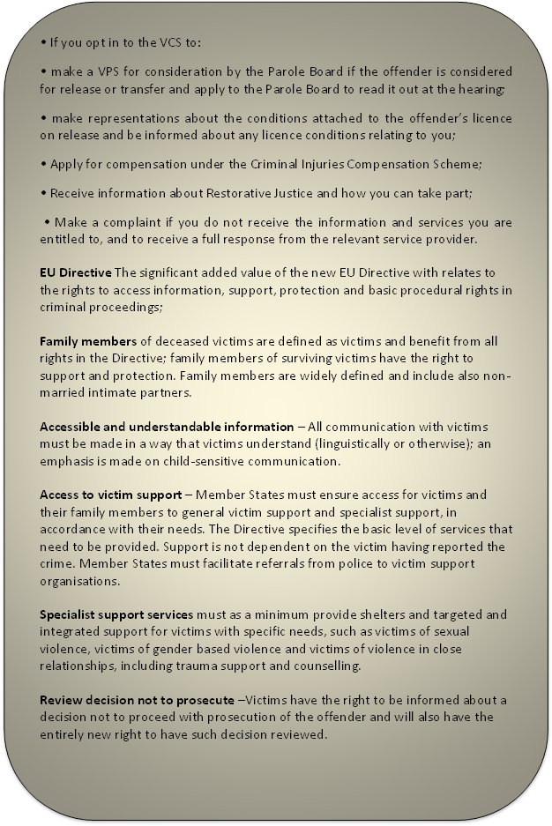

**Individual assessment to identify vulnerability and special protection measures** – All victims will be individually assessed to determine whether they are vulnerable to secondary or repeat victimisation or intimidation during criminal proceedings. If they have specific needs, a whole range of special measures will be put in place to protect them.  
  
Children are always presumed vulnerable and particular attention will be paid to some categories of victims such as victims of terrorism, organised crime, human trafficking, gender-based violence, violence in close-relationships, sexual violence or exploitation, hate crime and victims with disabilities.

**Strengthened rights and obligations compared to the Framework Decision**:

**Information rights** – Victims will receive a range of information from first contact with authorities. Victims will also receive information about their case, including a decision to end the investigation, not to prosecute and the final judgment (including the reasons for such decisions), and information on the time and place of the trial and the nature of the criminal charges.

**Interpretation and translation** - During criminal proceedings, victims with an active role have the right to interpretation and translation to enable their participation. Victims can challenge a decision not to receive interpretation and translation. All victims will receive a translation of the acknowledgement of their complaint.

**Protection of all victims is reinforced** – The privacy of victims and their family members must be respected and contact with the offender avoided (all new court buildings must have separate waiting areas).

**Restorative justice safeguards** –Victims who choose to participate in restorative justice processes (referred to as mediation in the Framework Decision) must have access to safe and competent restorative justice services, subject to some minimum conditions set out in the Directive.

**Training of practitioners** has become an obligation and emphasis is also put on cooperation between Member States and at national level and awareness raising about victims' rights.

**Annexe 2 – IDVA Case Study**

**Independent Domestic Violence Advice and Support Service**

**Impact Housing Association**

The couple have been together 14 years and mum reports physical and mental violence for all of their relationship.

Client reports that she has suffered mental abuse from XXXX from the onset of her relationship. Client reports that perpetrator has always misused alcohol since they met although she refers to this as binge drinking because he will not drink for a few days then binge on drink for up to 9 days at a time. This incident occurred following the perpetrator undertaking a 5 day drinking binge.

They have three children aged 10, 9 and 3.

The family originate from another area and mum and children have been in a refuge before following previous domestic violence.

She moved to Cumbria to be closer to her mother in law and the perpetrator followed and the couple reunited.

Client and the children have suffered significant emotional and physical abuse in the family home.

The client reports being petrified of her partner to the stage that she is afraid to leave the family home following Police involvement for fear of what he will do to her.

Client has rang the Police following a domestic incident at the home in which she suffered injuries to her face following being punched in the face by her partner and father of the children.

Police notified the IDVA service and children’s services.

Both IDVA service and children’s services made contact with client on the same day.

Perpetrator was charged, he pled guilty to common assault and remanded into custody pending a Newton Hearing.

Perpetrator, despite being given bail conditions, continually wrote to client and children from prison.

Client had to contact prison to request no further contact.

Client went to GP for medication to help with anxiety and depression.

Client is very isolated due to having no family and doesn’t work.

**Annexe 3 – ISVA Case Study - continued**

The ISVA liaised with Witness Care for Cara to collect her train tickets the day before the court appearance to avoid her bumping into the defendant who was travelling on the same train.

**27th June** Cara received a call from Witness Care (two days before trial scheduled to go ahead) to say that the trial had been adjourned again until October 2015 again.

CPS arranged a hearing with the judge for the next day to object to the delay. On the advice of CPS the ISVA communicated with the court to express dissatisfaction and concern at the number of adjournments associated to Cara’s case.

The ISVA received a call from CPS the following morning to say that the trial was back on for 29th June.

**29th June** Trial at Preston, the ISVA met Cara at the railway station as the defendant was going to be on the same train. The ISVA supported Cara in the witness rooms and in court giving evidence.

In court, the Judge had the ISVA’s communications and apologised to Cara for all the messing about.

The ISVA requested that the court delay release of the defendant for half an hour to avoid him being on the same train home as Cara. ISVA tracked the progress of the trial and prepared Cara for all eventualities. The perpetrator was found not guilty. The ISVA informed Cara of the outcome and continued her support until this was no longer needed.

The ISVA explained and supported Cara’s application to the CICA (Criminal Injuries Compensation Authority).

**Annexe 4-Example of what is going on in Carlisle around Poverty**

There are several church leaders in Carlisle who on a regular basis, accompany ‘offenders’ to court, support families while partners/ family members are in prison, provide additional ‘food banks’ to families of those in prison. At least two churches in Carlisle who have more than one sex offender in the congregation. Churches Together Op shops across the county provide another point of contact and will supply all sorts of practical help and clothes, white goods etc.

Churches Together are about to restart cooking for offenders through what was CROPT in St Barnabas

 When it comes to victims of DV several clergy have contacts and support women and their families, mainly in an informal way and the DV support group is taking off and having an impact, folks are referred by Let Go, they also self-refer now and knowledge of the group is spreading by word of mouth.

[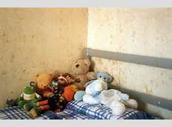](http://www.savethechildren.org.uk/sites/default/files/imported/childsbed.jpg) [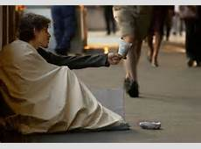](http://www.independent.co.uk/migration_catalog/article5182441.ece/ALTERNATES/w460/poverty.jpeg)

[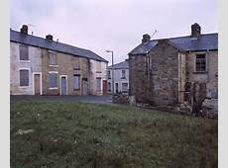](http://city-analysis.net/wp-content/uploads/2010/09/england_poverty.jpg)

The Meal bank below, which is a wonderful service to homeless and families from the women’s hostel and refuge in Carlisle, they are getting significant numbers but exact figures are unavailable.

Salvation Army, St Nicholas Hall  
Full meal Thursday lunch time, 12 midday. Open door.  
  
Op Shop, Botchergate (linked to St John's Church, Botchergate)  
Breakfast, Monday's, 9am-10am. £1.00, or donation, or free. Open door. (Except B/Hs)  
Evening meal, Tuesday's, 6.30-8.00pm. Open door.  
Monday-Saturday tea, coffee, cuppasoup available anytime.  
  
Hebron Church, 108 Botchergate  
Evening meal, 6-8.00pm. Families, couples, women (not single men). Voucher system.  
  
Gateway/ Church of Scotland, Doves Cafe  
Breakfast, Tuesday, 10-11.00am. £1.00. Open door.  
  
Cornerstones Cafe, Denton Home (linked to St James Church)  
Free tea and coffee any time.  
  
Foodbank, St Nicholas Hall  
Open Monday's, Thursday's and Fridays, 1-3pm. Referral system.

SVP Food Parcels

Once again St Margaret Mary SVP will be distributing food parcels for families in need before the start of the school summer holidays. We hope to distribute parcels in the week beginning Monday 13th July.

Sacred Heart of Jesus Church-Meals at the Parish Centre

Wednesday 10.00 am - 2.00 pm and Sunday 12.00 noon - 3.00 pm.

Food vouchers  
Can be exchanged for a full meal at 3 locations in Carlisle (written on the vouchers).  
Doners can obtain a supply of vouchers via Carlisle One World Centre, £7.00 each.

Main referrers: Civic Centre, Citizens Advice, Gateway, Unity, Carlisle Key, Carlisle Hostels.

**Annexe 5- Court Closures and the impact on victims**

1 Vulnerable victim of domestic abuse. Victim had 3 children, 2 of school age and a younger child. Victim was scared and very nervous about attending court to give evidence against her ex-partner. To try and ease her concerns Victim attended Barrow Court for a Pre Trial Visit with the Witness Service to familiarize herself with the court, where the witness service rooms are, where she would be giving her evidence from, who would be standing where etc. Witness Service re-assured her and arranged to meet her at the entrance of the court on the trial date. At 4pm on the evening before the trial the victim received a call from the Witness Care Unit to say that the trial had been re-located to Preston.

**Issues:**

* Immediate re-action-“I can’t go”
* Panic/Stress
* Fear of not knowing where the court was in Preston
* Fear of not knowing how she was going to get there
* Concern about whether she had enough money to cover transport costs to get there.
* Child Care- she would need to leave earlier than expected and be back later than anticipated so who would look after the children and take the two older ones to and from school, feed them etc.
* She didn’t know the lay out of the court or the Witness Service in Preston-no-one would meet her at the door as previously arranged.
* Impact on her and her family
* Cost to the public purse

2 Vulnerable victim of rape-Case was listed for trial and adjourned 3 times on the basis that on 3 separate dates when the jury was sworn in, a member of each of the juries was allegedly recognized by the defendant and the case was subsequently transferred out of area. On each of these occasions the victim had travelled a significant distance to court and then had the added ordeal of having to travel to an unfamiliar court in an unfamiliar area for the trial.

**Issues:**

* Anxiety/Stress
* Disappointment
* Fear of not knowing where the court was
* Fear of not knowing how she was going to get there
* Concern about whether she had enough money to cover transport costs to get there.
* She didn’t know the lay out of the court or the Witness Service in the area she was going to.
* Cost to the public purse

3 Vulnerable victim of rape in West Cumbria **-**The offender in this case pleaded guilty at court on the day on which the trial was listed, at the last minute at in April. The victim had been seriously affected by the rape, suffered depression, missed a year of her apprenticeship ,she was aware that she didn’t have to attend the sentencing but wanted to in the hope that it would bring some closure for her however the delays caused her and her family more stress and anxiety. Sentencing was adjourned on 3 occasions. On one occasion a production order had not been requested for the offender who was on remand in Bath for breach of bail. On another occasion the video link between the court and the prison didn’t work and on the last occasion the Judge said that she wanted the offender present in court for the sentencing. The victim said that on one occasion she and her mum and dad were just around the corner from the court when they received a phone call from the officer in the case who had only just learned of the adjournment and was checking that they had been informed that the sentencing was cancelled that day.

**Issues**

* Anxiety/Stress
* Disappointment
* Personal Financial Cost
* Impact on her and her family

4 Vulnerable victim of hate crime with learning difficulties from Maryport who was on benefits wanted to attend for a pre court visit prior to the trial. Funding was made available for him to travel for the Pre Court visit but not for his friend, the 3 vulnerable witnesses who also had learning difficulties.

5 Victim aged 80years travelled from Egremont to Workington for a pre court visit, this involved an hours bus journey on 2 different buses with a 20 minute walk from the bus station to the court, it was the same return journey. If this victim has to travel to Carlisle for a pre court visit her bus journey will be between 2hours 44 and 2hours 57 minutes with a 10 minute walk to the court and the same for the return journey.

THINGS TO CONSIDER

Travelling great distances to court is a common occurrence.

Victims and Witnesses can claim their costs; however the costs of travelling to and from court are going to get bigger.

Victims will not be able to afford transport costs and they will need to be paid in advance.

Having to travel greater distances to court may result in victims and witnesses not turning up and a bigger waste of court time.

The geography of the county already causes issues for victims having to travel to court on the same public transport as defendant’s, this will be exacerbated if courts close.

Giving evidence from remote locations has been mentioned, Ii is understood that these will also be available to defendants-who will police them? There will be no security or witness service at the remote locations.

If victims and witnesses don’t turn up at court, will this involve more summonses being issued? Are we then going to criminalize innocent people? This would also cause more expense and mean more work for the police.

Are all courts suitable for defendants who may be disabled? (such as being fitted with a lift to get them to the dock).

1. Community Safety Strategic Assessments for Barrow, Copeland, Carlisle and Allerdale – October 2015
2. Cumbria Constabulary Crime Data 2015
3. Crime and Community Safety Strategic Assessment for Cumbria – October 2015
4. Cumbria Constabulary – Performance Report November 2015
5. Cumbria Constabulary data – April 2011 to March 2015
6. Victim Services data 2015
7. Cumbria Constabulary Crime Data April 14 to March 15
8. At Risk, Yet Dismissed – Kings College London & Victim Support
9. Joint Strategic Needs Assessment Summary 2015-17
10. Health Profile 2015 – Public Health England (Data recorded for 2012/13)
11. House of Commons, Home Affairs committee – 12 report ‘Drugs: New Psychoactive Substances & Prescriptions Drugs
12. Cumbria Constabulary Crime Data
13. Public Health England ‘Local alcohol profiles for England’ 2015
14. Cumbria Health Profile 2014 – Public Health England
15. Crime and Community Safety Strategic Assessment for Cumbria – October 2015
16. Cumbria Constabulary crime system 2015
17. Pg 17 Crime and Community Safety Strategic Assessment for Cumbria October 2015 [Cumbria Constabulary Force Strategic Assessment 2014]
18. Cumbria Constabulary – Hate Crime Problem Profile – December 2015
19. Cumbria Constabulary – Hate Crime Problem Profile – December 2015
20. Information provided by Cumbria Constabulary
21. Cumbria Constabulary – Performance Report November 2015
22. Cumbria Constabulary – Performance Dashboard
23. Cumbria Constabulary Domestic Violence Problem Profile
24. Let Go data – April 2014 to March 2015
25. Freedom Data – April 2014 to March 2015
26. Home Office Consultation Paper on Harassment and Stalking
27. Victim Support Data – April 14 to March 15
28. Safety Net Data – November 13 to October 14
29. Crime and Community Safety Strategic Assessment – October 2015
30. Cumbria Constabulary: Force Strategic Assessment, 2014.
31. Cumbria Constabulary Crime Data – April 14 to March 15
32. Cumbria Constabulary Performance Report – November 2015
33. Crime and Community Safety Strategic Assessment for Cumbria – October 15
34. Cumbria Constabulary Crime Data – April 14 to March 15
35. Crime and Community Safety Strategic Assessment – October 2015
36. NFU financial claims data 2014
37. Cumbria Constabulary Crime Data – April 14 to March 15
38. Cumbria Constabulary Performance Report – November 2015
39. National Rural Crime Survey 2015
40. Cumbria Constabulary Crime Data – April 14 to March 15
41. OPCC Anti-Social Behaviour Questionnaire for Police Officers 2015
42. Cumbria Constabulary – Performance Report November 2015
43. Crime and Community Safety Assessment 2015 – Cumbria Road Safety Partnership 2015