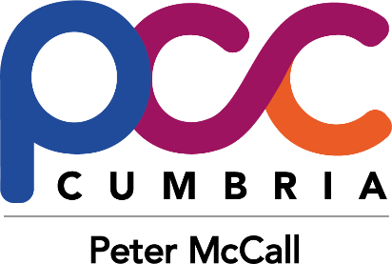

Police & Crime Commissioner for Cumbria
Awards 2017
Nomination Form
(Please complete all sections below, failure to do so may result in your nomination not being considered.
Only one category per nomination form)
Please state which award you are making the nomination for:
- Outstanding Citizen
- Outstanding Young Citizen
- Outstanding Community Project
- Outstanding Volunteer Award
- Outstanding Team or Outstanding Professional
Who are you nominating?
(Please provide full names of the individual/s or team you are nominating)
Contact details for person / people you are nominating?
If you are nominating a group, please list all the names of those involved:

Please confirm that the person(s) nominated have been made aware (Please tick the box to

and are agreeable to this nomination confirm)
Does your nomination relate to work in the public, private or voluntary sector?
Your name, full contact details including email address & relationship to nominee(s):

Date of Nomination:

- Please provide a brief description of the outstanding contribution made by the nominee(s), including when the work took place, and in which area of the county (Max 250 words)

- Please provide a brief description of the impact this work has had on the community, including any evidence or feedback you may have to demonstrate this (Max 250 words)

- Please provide a brief explanation of how you think this work supports one or more of the areas of focus contained within the Commissioner’s Police and Crime Plan. Some areas are listed below for you (Max 250 words)
- Tackling crime and Antisocial Behaviour
- Supporting Victims of Crime
- Ensuring offenders face a consequence of their crime
- Supporting Young People
- Tackling grooming and child sexual exploitation
- Improving services for people with mental health conditions, reducing the demand of crisis situations
- Tackling domestic abuse

NB: The Full Police and Crime Plan can be read online or downloaded here:
https://cumbria-pcc.gov.uk/your-pcc/police-and-crime-plan/

Please submit your nomination by email to commissioner@cumbria-pcc.gov.uk or by post to:
Police & Crime Commissioner for Cumbria
1-2 Carleton Hall
Carleton Avenue
Penrith
CA10 2AU

All submissions must be received by the Office of the Police and Crime Commissioner by no later than 12.00 noon on Friday 28 April 2017.

