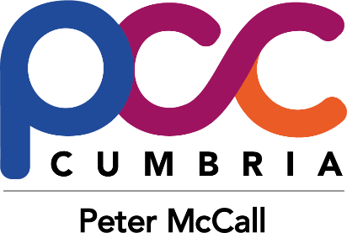

Police & Crime Commissioner’s Awards
Terms and Conditions

1. The closing date for the Commissioner’s Awards 2017 is 28 April 2017 at
12 noon. No entries received after this time, either online or hard copy,
can be considered.
a. If you are posting the form, then please allow a few days for the form to arrive before the deadline.
b. If you are submitting an electronic form via email please allow plenty of time for the email to be received. Do not leave it until 12 noon to submit as we may not receive it through our security systems.
2. The Office of the Police and Crime Commissioner cannot be held
responsible for any nominations that are not received due to postal delays or computer issues such as connection issues or outdated software/ hardware or hard copies being mislaid by the postal services.
3. If you wish to make nominations for more than one category please complete and submit a separate form for each of the categories.
4. The Office of the Police and Crime Commissioner can only accept nominations on the approved nomination form. We will not be held responsible for returning any supporting evidence that is sent with the nomination forms. It is advised that copies of any supporting evidence be sent in replace of originals.
5. All nominations must be for either a person or a group of people running projects, businesses, charity etc and must involve people. We cannot accept nominations for animals, buildings or locations.
6. All individuals that are nominated must not be deceased at the time of the nomination. If the nominated becomes deceased once the nomination is submitted, then they will continue through the process unless the nomination is withdrawn or personal circumstances dictate that the nomination is discontinued.
a. A group or project that include a deceased member of the team at time of nomination is acceptable.

7. The person(s) / group / project / charity / business you nominate must operate in the Cumbria county boundary.
a. Eg. A sports volunteer who helps at a group within the boundary but lives in another county, would be eligible.
b. Eg. A business could be nominated for the Outstanding Team or Outstanding Professional, as long as they operate in the boundary and also contribute to the area within the boundary, even if their head office is in an another county.
8. Please note, the award winners are selected at the PCC's Judging Panel’s discretion - not on the number of nominations received.
9. Names of the winners of each category and any photographs taken at the awards ceremony will be published within the media.

