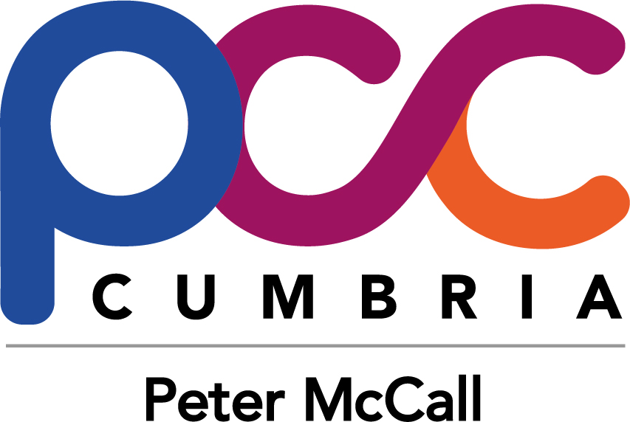

Cumbria Youth Commission on Police and Crime 2019
CONSENT FORM
If you are under 18, please ask a parent/guardian/carer to complete and sign this form. Please make sure they have read the Application Guidance Notes and understand what’s involved in the project.

I consent to [NAME] ………………………………………………………………………………………… becoming a member of Cumbria Youth Commission on Police and Crime in 2019

Parent/guardian name (PRINT) …………………………………………………………………………………………………………………

Parent/guardian signature………………………………………………………………………………………………………………………..

Relationship to applicant …………………………………………………………………………………………………………………………

Date…………………………………………………………………………...................................................................................

Contact telephone number……………………………………………………………………………………………………………………….

E-mail……………………………………………………………………………………………………………………………………………………….

This form can either be submitted at the first event on 18th May 2019 or scanned and emailed to ali@leaders-unlocked.org

