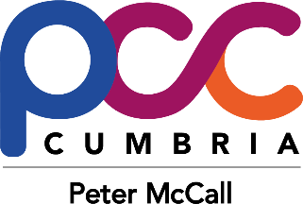
Safer Streets Fund Round 2
Workington
St Michael’s Ward

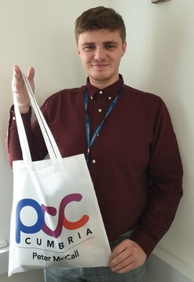
Work is continuing despite the rainy weather to deliver Safer Streets to St Michael’s ward.
249 residents so far have received safer homes packs containing security items, property marking kits and information to help keep homes safer and deter thieves. If you would like to receive a safer home pack as displayed here by team member Jackson, please contact the Safer Streets Team.
Email saferstreets@cumbria.police.uk
Telephone 0300 124 0112 ext 44492
www.cumbria-pcc.gov.uk/what-we-do/funding/safer-streets-fund

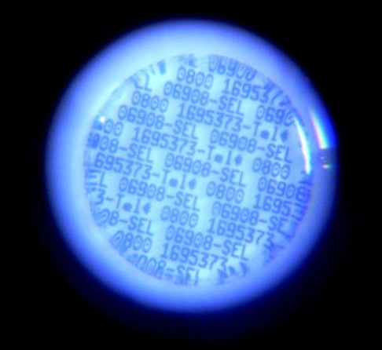
Property marking itself cannot prevent a burglary from happening, but it does act as a deterrent to most thieves. Each safer homes pack contains a SelectaDNA property marking kit - a pot of unique microdots which can be painted inconspicuously onto your possessions and the kit registered to your address. When property is marked and window stickers are displayed, this announces that goods inside this property are marked. The marked goods are traceable and so have little resale value, which puts off most burglars. If police recover any marked stolen goods, they can check the property register to identify the rightful owners, and the extra bonus is that they also have evidence to support a prosecution.

Our Safer Streets team can visit your home and carry out a home security survey to identify any weaknesses which may make your home more tempting to burglars. The team will discuss any concerns and make recommendations to help keep your home safer. If any work is recommended, the team can arrange for the work to be carried out with the project meeting the costs (subject to agreement of the homeowner, value of the work, and the understanding that the project is not liable for upkeep or repairs) If you would like to have a trained team member visit your home to give you that peace of mind, please contact the Safer Streets Team.
Email saferstreets@cumbria.police.uk
Telephone 0300 124 0112 ext 44492

