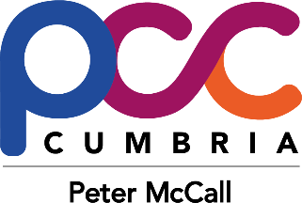
Safer Streets Fund 2
Workington
November Update

Progress so far
- Safer Streets Assistants have delivered 249 Safer Homes Packs to residents out of our target of 1300.
- A training video is being developed under the guidance of our Crime Prevention Officers to help police officers to understand the scenarios where the UV torches would be beneficial.
- Safer Streets Assistants have carried out 51 Home Security Surveys out of our target of 150.
- Security improvements for these homes are being procured by the OPCC.
- Street lighting and public realm lighting is still on schedule with Cumbria County Council.
- CCTV has been installed and is operational at St Michael’s Nursery and Infant School.
- The school children have drawn posters of safer streets for a competition to being judged by Mr McCall.
- The Q2 return has been made to the Home Office.

Issues
- Electricians are in high demand, so it is taking longer to get quotes and carry out the work, but we still have sufficient time for the work the be carried out before the end of the project.
- One of the Safer Streets Assistants has left the project, so ideas are being explored to ensure the delivery of the project remains on target. 3 student officers are assisting for a 3-week period as part of their course. PCOSs are being offered an overtime opportunity. The use of Constabulary volunteers is being considered.

