Out of Court Disposal
Scrutiny Panel
Annual Summary 2021

Background:

The Cumbria ‘Out of Court Disposal Scrutiny Panel’ was established in November 2013 and is currently chaired by the chief executive of the Office of Police and Crime Commissioner. Cases submitted to the panel are selected independently from anonymised data by a magistrate from the Out of Court Disposal Scrutiny Panel facilitated by a representative of the Crime Reduction & Criminal Justice Partnership and overseen by a delegate from the Office of Police and Crime Commissioner. This ensures transparency, maintains public confidence, and allows the system to have credibility in Cumbria Constabulary’s desire to be open and accountable.
Out of Court Disposals allow the police to deal quickly and proportionately with low level, often first time, offending which can be appropriately resolved without a prosecution at court. Delivered ethically, effectively, to the right people and in the right circumstances they provide swift and meaningful justice for victims, hold offenders accountable for their actions and reduce re-offending. The aim of the panels is to determine whether the method of disposal is considered appropriate, based on a review of the information/evidence available to the decision maker at the time. The panel considers the offence category and severity of offence, evidence present at the time of disposal, rationale in officers’ decision-making process and whether decisions were victim focused.
Covid-19 has been present again this year and it still impacts our day-to-day life. From the first lockdown in March 2020, right up to the current day we continue to face challenges in the way we carry out our daily business. The nature of our work is constantly evolving, crime does not stop and neither does our police force. Returning to a “new normal” in all of our work requirements has seen us embrace new technological and innovative ways to continue to meet our responsibilities as a Police Force and Police and Crime Commissioner.

Purpose and processes:
The purpose of the scrutiny panel is to independently review a selection of anonymised cases that have been resolved by use of an out of court disposal. The scrutiny panel has no referral or appeals capability and is not intended to re-judge cases. It assesses the relevant processes, interactions, and decisions to identify any areas for development and to promote continuous organisational learning.
The panel members discuss each case, identify any areas that could be improved or require additional information, and either agree or disagree with the disposal decision. Where the panel has identified learning issues, these are tasked as action points for individual panel members to take forward.
The panel continues to acknowledge the implications of conducting dip samples on a small number of overall cases; however, it must also be recognised that alongside cases identified as having been handled in line with policy, there are cases where inappropriate and inconsistent disposal options have been identified and these findings lead to improved knowledge and understanding of disposal options.
Terms of Reference:
The Terms of Reference have been reviewed by panel members for the years business and approved them at our February meeting prior to publication. The Terms of Reference for 2021 are included here: .
Statistical summary of findings:
Overall Table of all recorded Out of Court Disposals from 01 Jan 2021 – 31 December 2021
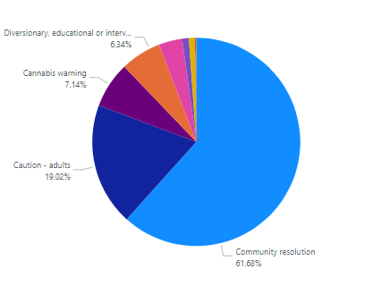

Offence groups which had Out of Court Disposal outcomes from 01 January 2021 – 31 December 2021
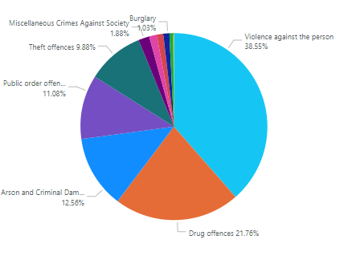

Cumbria Constabulary recorded 34,426 crimes in 2021. 5025 of these had positive outcomes, of which 1751 (34.85%) were Out of Court Disposals.
94 independently selected cases were audited across 3 meetings during 2021 which equates to a dip sample of 4.5% of available cases. Overall, 88 cases were found to have a disposal that was both appropriate to the offence and consistent with national guidelines and local policy, which is 93% of the cases that were selected.

This compares to 78% in 2020 and 85% the previous year. Positive feedback was provided to a number of officers and their supervisors in cases that stood out due to the quality of the work undertaken. In particular, praise was given when it was clear that all the options had been thoroughly considered including multi-agency approaches and referrals to support schemes, that the victim’s views had been taken into consideration, that the decision-making rationale was clearly explained, and that it was easy to establish from the documentation what actions had been taken.
2 cases were deemed to have an inappropriate outcome and were inconsistent with policy, 4 cases were deemed to be inappropriate but consistent with. In all these cases feedback was provided to the officers involved and to supervision to allow growth of knowledge and further improvement.

Adult Cautions:
Adult Cautions (adult simple cautions) made up the majority of the disposals of the cases that the panel examined, with 55 out of the 94 cases scrutinised, having this disposal recorded. Of the 55 cases audited, 51 cases or 92% were considered to be appropriate and consistent with policy, the previous year was 76% with 85% in 2019. 7% were believed to be inappropriate and inconsistent with policy, which is lower than the 16% figure for the previous year.
Adult Conditional Cautions:
The panel scrutinised two Adult Conditional Cautions during 2021 both were found to be appropriate and consistent with policy. No Adult Conditional Cautions had been scrutinised in the previous year.
Youth Conditional Cautions:
Seven Youth Conditional Cautions were reviewed over the course of the year, and all were found to be appropriate and consistent with policy, this was the same 100% outcome as both 2020 and 2019.
Community Resolutions:
19 Community Resolutions were audited during 2021, of which 17 or 90% were considered to be appropriate and consistent with policy, compared to 78% in 2020 and 74% the previous year. 10% of the Community Resolution cases overall were found to be inconsistent with policy compared to 11% last year and 22% for 2019.
Deferred Cautions – Outcome 22 (Pathways)
There were 5 Deferred Cautions audited in the November 2021 Panel meeting with all five found to be appropriate and consistent with policy. As Pathways is a new way to assist offenders out of crime and re-offending, there is no comparison yet available year on year.
PND and Cannabis Warnings:
Only one PND disposals was considered, it was deemed to be appropriate and consistent with policy.
The panel did not audit any Cannabis Warnings this year.
Examples of Lessons Learned:
Feedback is routinely cascaded out following the scrutiny of cases. This can be for cases that could have been handled differently and this is either utilised corporately in police training or through internal notices to assist organisational learning, or individually to the officers concerned and their supervisors. Correspondingly, the panel has seen many examples of excellent work and has provided positive feedback to the Constabulary and the officers involved.
Theft by an employee – Deferred Caution – Pathways
The case concerns a shop keeper noticing a shortfall in the till of £200. On return to work the offender was asked about the missing money. The offender admitted to stealing some sweets and £50 cash but stated they had not stolen £200.
When the offender was interviewed by the Police they admitted to the thefts in their entirety. They were very remorseful and was very willing to embark on the Pathways programme. They did state they had written to the victim twice to apologise for what they had done and offered to pay the money back.
The offender engaged well in Pathways and took part in everything they needed to such as the assessment and the Restorative Choices programme. They have a good family background and no other concerning factors when assessed. The offender gave positive feedback about Pathways. All agreed it was a great outcome to this investigation.
Stalking involving serious alarm/distress - Community Resolution
This offence related to a 15 yr. old male in a relationship with a 16 yr. old female. When female has tried to end relationship, the male offender has continued to contact female victim. The offender has then stated that if the victim didn’t keep in touch that he would circulate images of the female on social media and indeed went on to do so. This caused the victim a lot of distress. The offender was visited by the Child Centred Policing team and YOS and was spoken to with his father present. The Offender had not realised the seriousness of the offences he had committed. There have been no further incidents since the intervention. The panel agreed this was a good decision for this disposal and great intervention with the offender.
Cruelty to or Neglect of Children – Adult Caution
This offence relates to a parent who has issues with alcohol addiction issues, engaging in an argument with their daughter. The victim (daughter) has tried to remove herself from the argument which was escalating because of the parent’s intoxication. However, parent has blocked her way, leading to the daughter biting parent to make them move. Parent has then hit the victim causing her to lose balance and bang her head. The victim has sustained bruising to her head and a black eye. Initial safeguarding has been addressed and parent was arrested. This is the first offence committed by parent and it was decided that although there was a realistic prospect of conviction in the case, there would be some evidential difficulties around the young victims. It was decided an Adult Caution for Child Neglect would be the best outcome for this investigation. More involvement with Children Services would be considered around a whole family approach and to consider more Restorative Justice in these cases.
Wounding with intent – Youth Conditional Caution
Victim and witness met at a quarry and were then approached by five other males, including the suspect. Offender has then assaulted the victim in a premeditated and prolonged attack. The incident is believed to have been captured on a mobile phone. All were 13 years old. Offender had no previous convictions and has been willing to address his behaviour. The Youth Offending service has confirmed that the young person has successfully completed intervention offered to him which was tailor made to his needs. Offender would have received the same intervention if a referral order had been made.

